

**Department of Electrical and Computer Engineering**

**ENCS3320 - Computer Networks**

**Summer Semester 2023/2024**

**Project#1: Socket Programming**

**Prepared by:**

Mouath Masalmah - 1220179

Zaid Mousa - 1221833

Bahaa Bani Shamsaa - 1220252

**Instructor:** Dr.Ibrahim Nemers

**Section:** SECTION_1

# Task 0:

| **Subnet** | **Subnet Mask “/x”** | **Network IP** | **Broadcast IP** | **First IP** | **Last IP** | **#hosts** |
| --- | --- | --- | --- | --- | --- | --- |
| **NET 1** | 255.255.255.224/27 | 179.01.8.64 | 179.01.8.95 | 179.01.8.65 | 179.01.8.94 | 30 |
| **NET 2** | 255.255.255.196/26 | 179.01.8.0 | 179.01.8.63 | 179.01.8.1 | 179.01.8.92 | 60 |
| **NET 3** | 255.255.255.224/27 | 179.01.8.96 | 179.01.8.127 | 179.01.8.97 | 179.01.8.126 | 30 |
| **NET 4** | 255.255.255.240/28 | 179.01.8.128 | 179.01.8.143 | 179.01.8.129 | 179.01.8.142 | 14 |
| **R0-R1 LINK** | 255.255.255.252/30 | 179.01.8.144 | 179.01.8.145 | 179.01.8.146 | 179.01.8.147 | 2 |
| **R0-R3 LINK** | 255.255.255.252/30 | 179.01.8.156 | 179.01.8.157 | 179.01.8.158 | 179.01.8.159 | 2 |
| **R1-R2 LINK** | 255.255.255.252/30 | 179.01.8.148 | 179.01.8.149 | 179.01.8.150 | 179.01.8.151 | 2 |
| **R2-R3 LINK** | 255.255.255.252/30 | 179.01.8.152 | 179.01.8.153 | 179.01.8.154 | 179.01.8.155 | 2 |

## Part1:

### 1.How we define IP

* We used the IP of one of the members, which is IP 1220179, where we took the last 2 bits and put them first (ex: 179.01.8.64) and took the 2 before the last and put them in the second (ex: 179.01.8.64).

### 2.IPv4

* Internet Protocol version 4 ( IPv4 ): is a core system that enables communication between devices on the Internet. It uses 32-bit addresses, allowing for about 4.3 billion unique combinations. These addresses are typically written as four numbers separated by dots, like `179.01.x.x`, where each number can range from 0 to 255.

### 3.The Network Part

* The **Network Part** of an IP address identifies which network a device is on. Routers use this part to send data to the correct network. For example, in `179.01.8.1` with the subnet mask `255.255.255.0`, the first two numbers `179.01` are the network part.

### 4.The Host Part

* The **Host Part** pinpoints the specific device within that network. It’s unique to each device on the same network. In the same example, `8.1` is the host part, identifying the particular device.

## Part2:

1. **Identify the Required Subnets:**

- Start by identifying the number of subnets required and the number of hosts needed in each subnet. In this case, we have four main subnets (NET 1, NET 2, NET 3, NET 4) and four point-to-point links (R0-R1 LINK, R0-R3 LINK, R1-R2 LINK, R2-R3 LINK).

2. **Determine the Subnet Mask:**

- Based on the number of hosts required, select the appropriate subnet mask.

- For example:

- **NET 1:** Requires 30 hosts, so a /27 subnet mask (255.255.255.224) is suitable.

- **NET 2:** Requires 60 hosts, so a /26 subnet mask (255.255.255.192) is suitable.

- **Point-to-Point Links:** Require 2 hosts each, so a /30 subnet mask (255.255.255.252) is appropriate.

3. **Calculate Network, Broadcast, and Usable IP Addresses:**

- Using the subnet mask, calculate the network address, broadcast address, and the range of usable IP addresses for each subnet.

- For example, for **NET 1**:

- Network IP: 179.01.8.64

- Broadcast IP: 179.01.8.95

- Usable IPs: 179.01.8.65 to 179.01.8.94

4. **Fill in the Table:**

- For each subnet, fill in the table with the calculated values. Ensure the broadcast IP is correct, and the first and last usable IPs are within the correct range.

5. **Verify IP Allocation:**

- Double-check that no IP addresses overlap between subnets and that all IPs are accounted for.

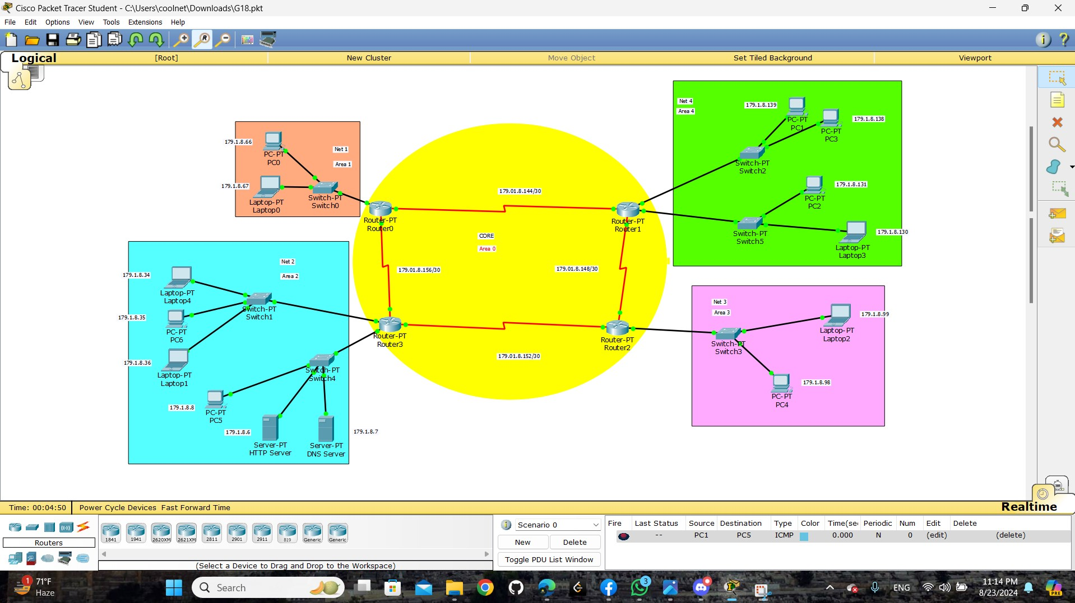

## Part3:

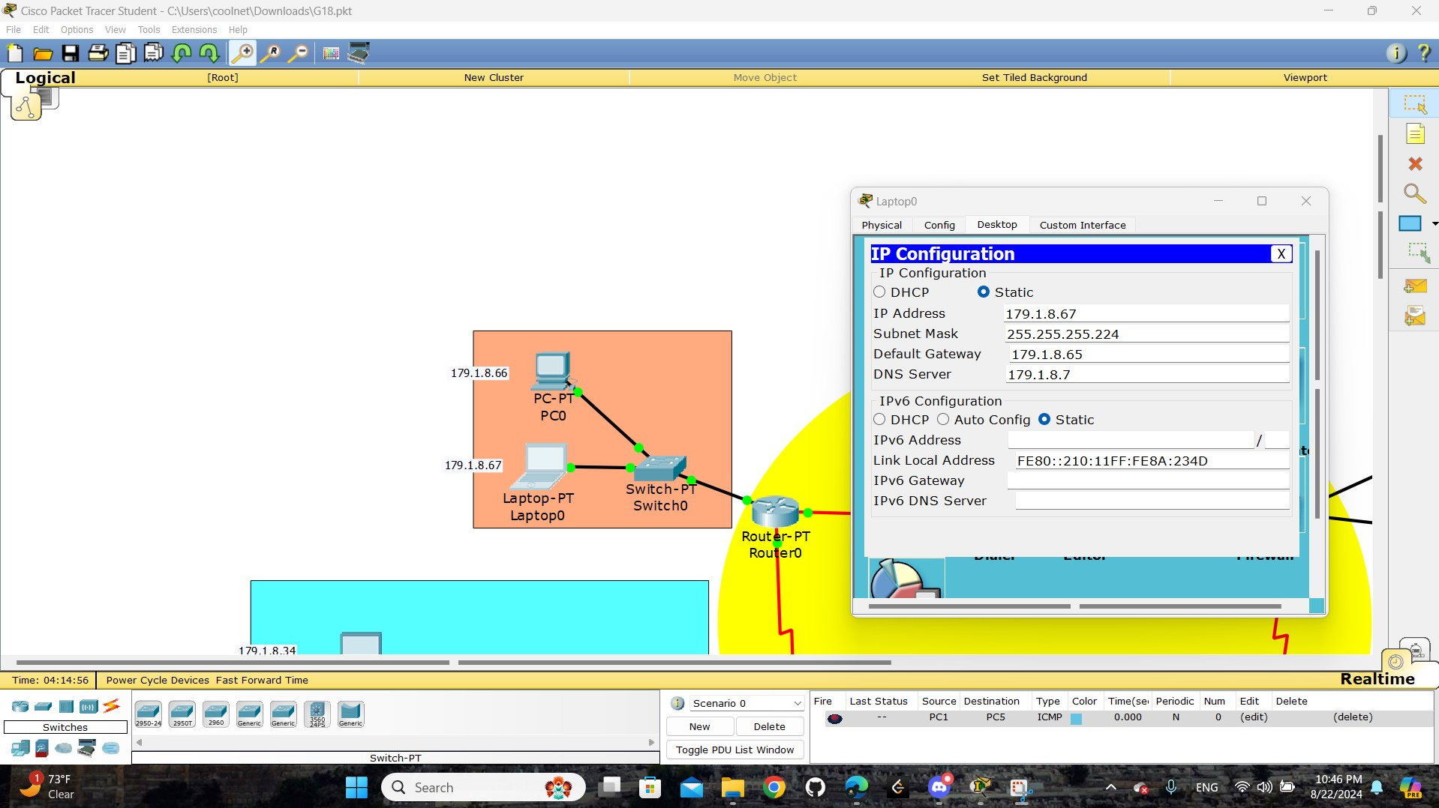

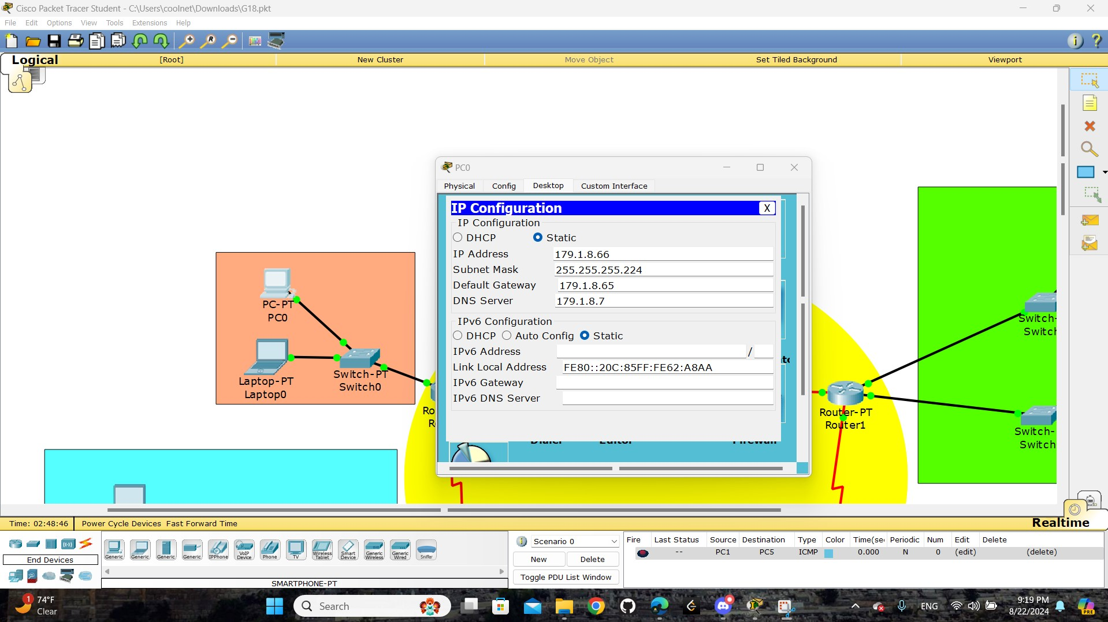

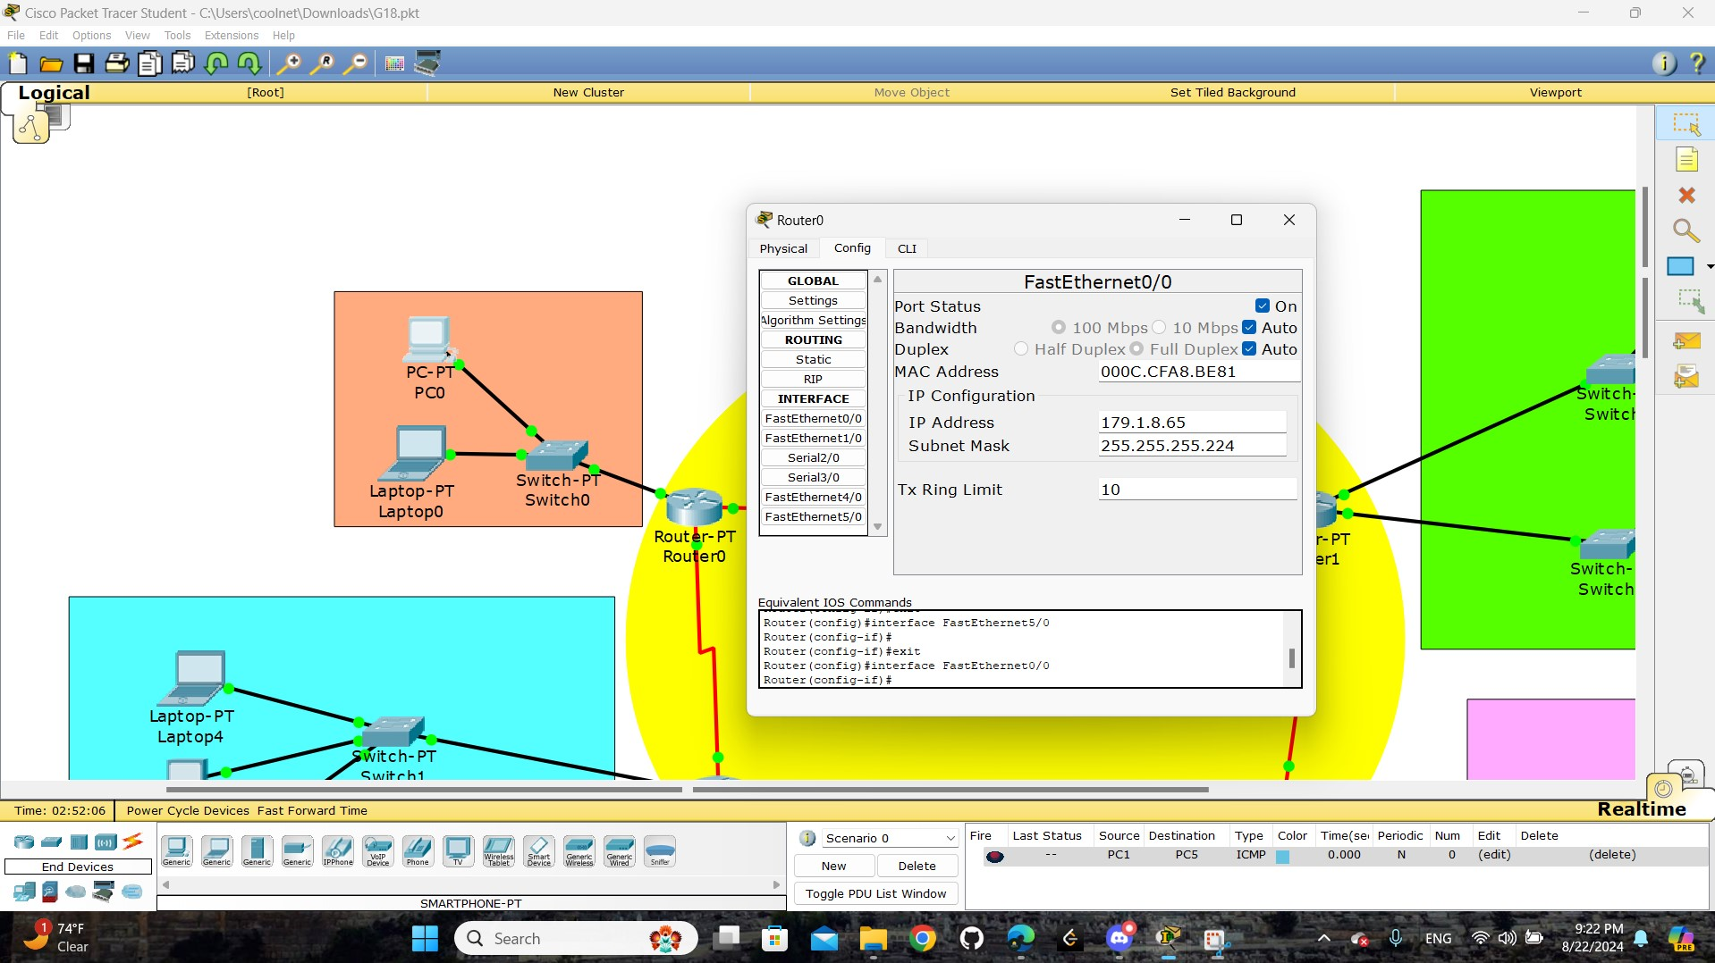

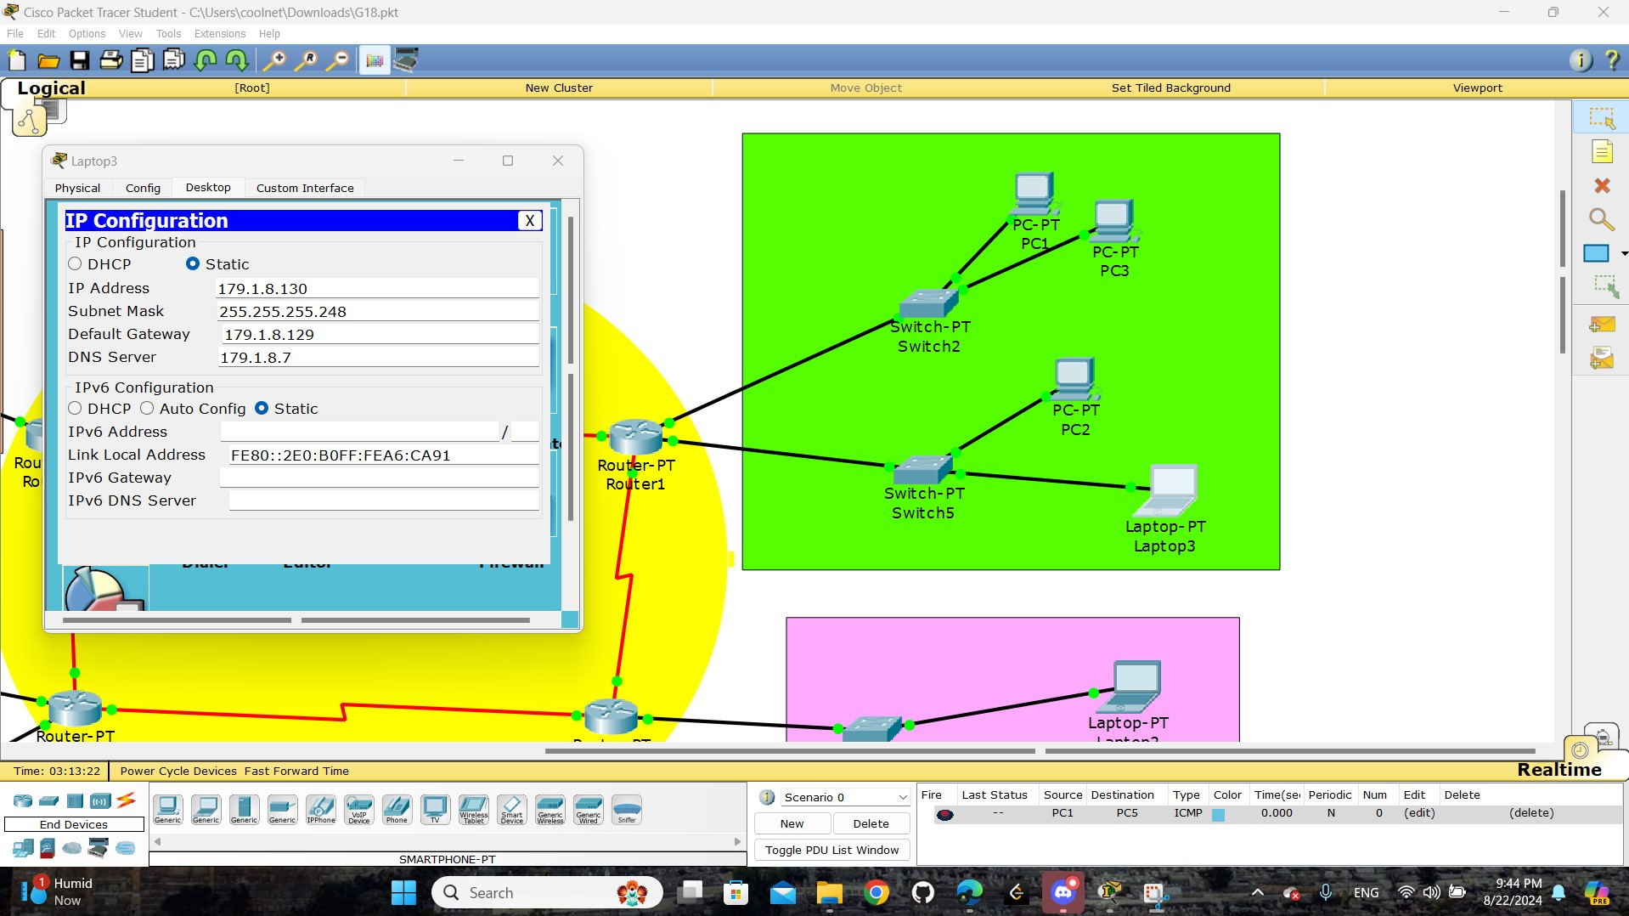

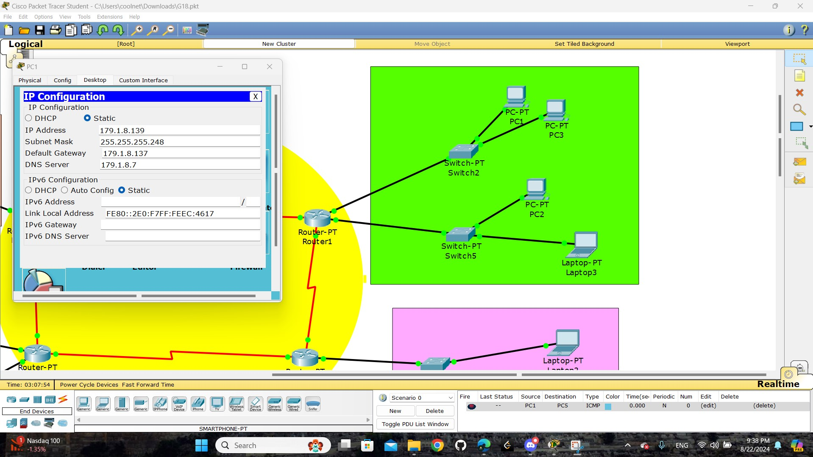

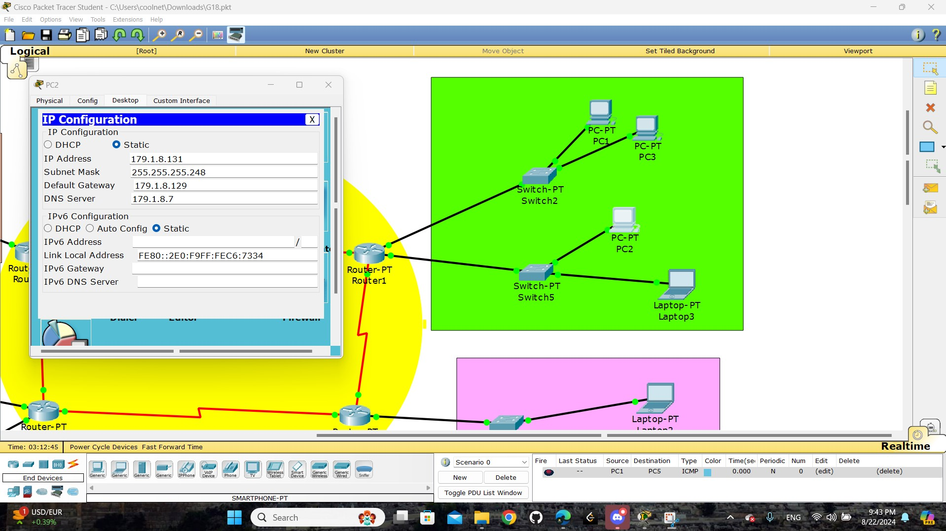

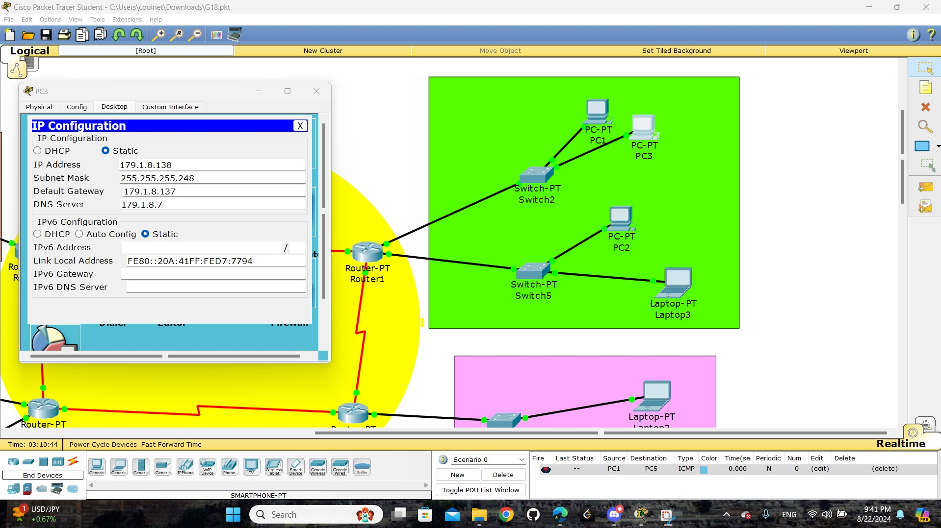

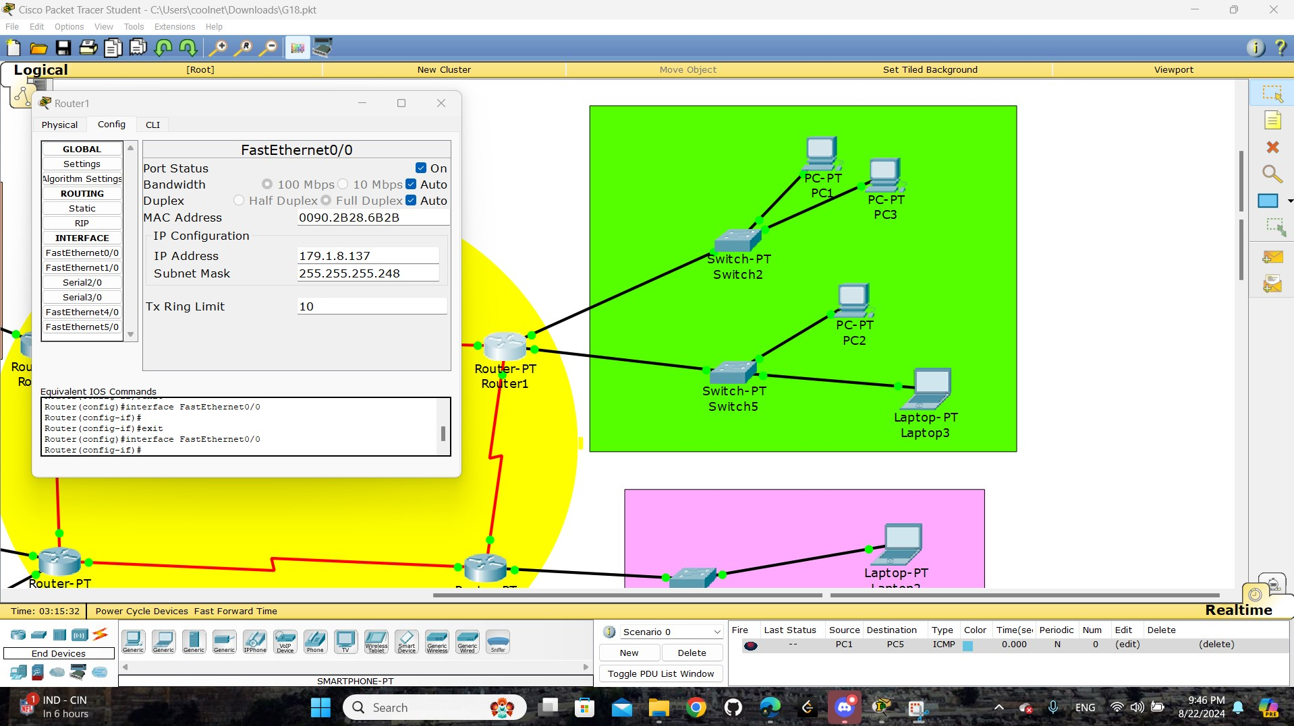

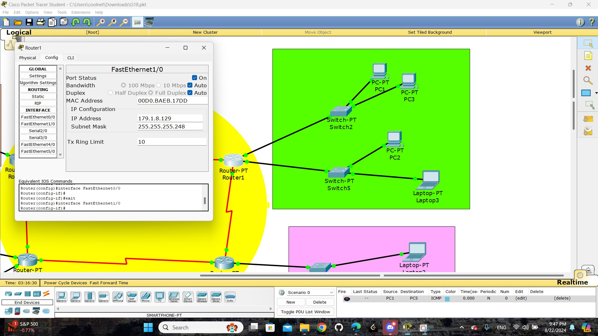

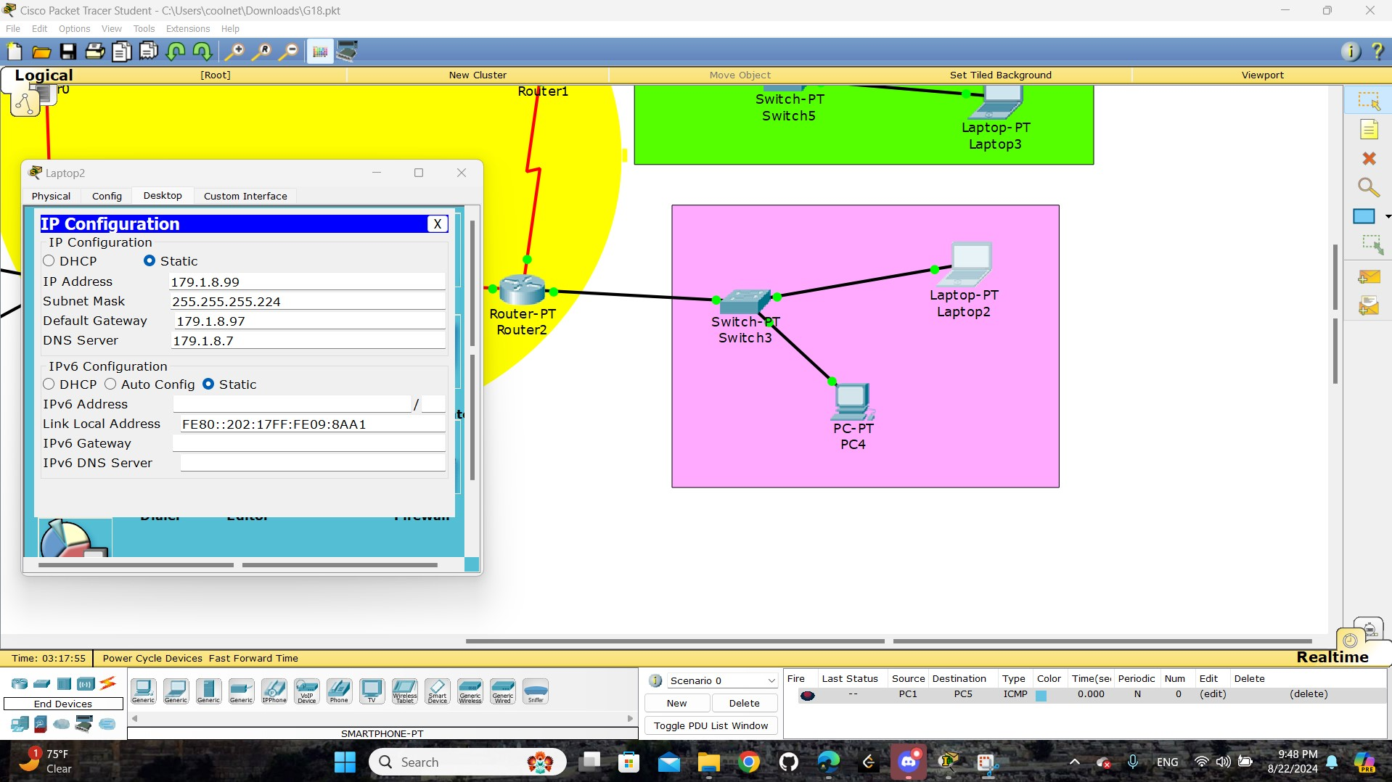

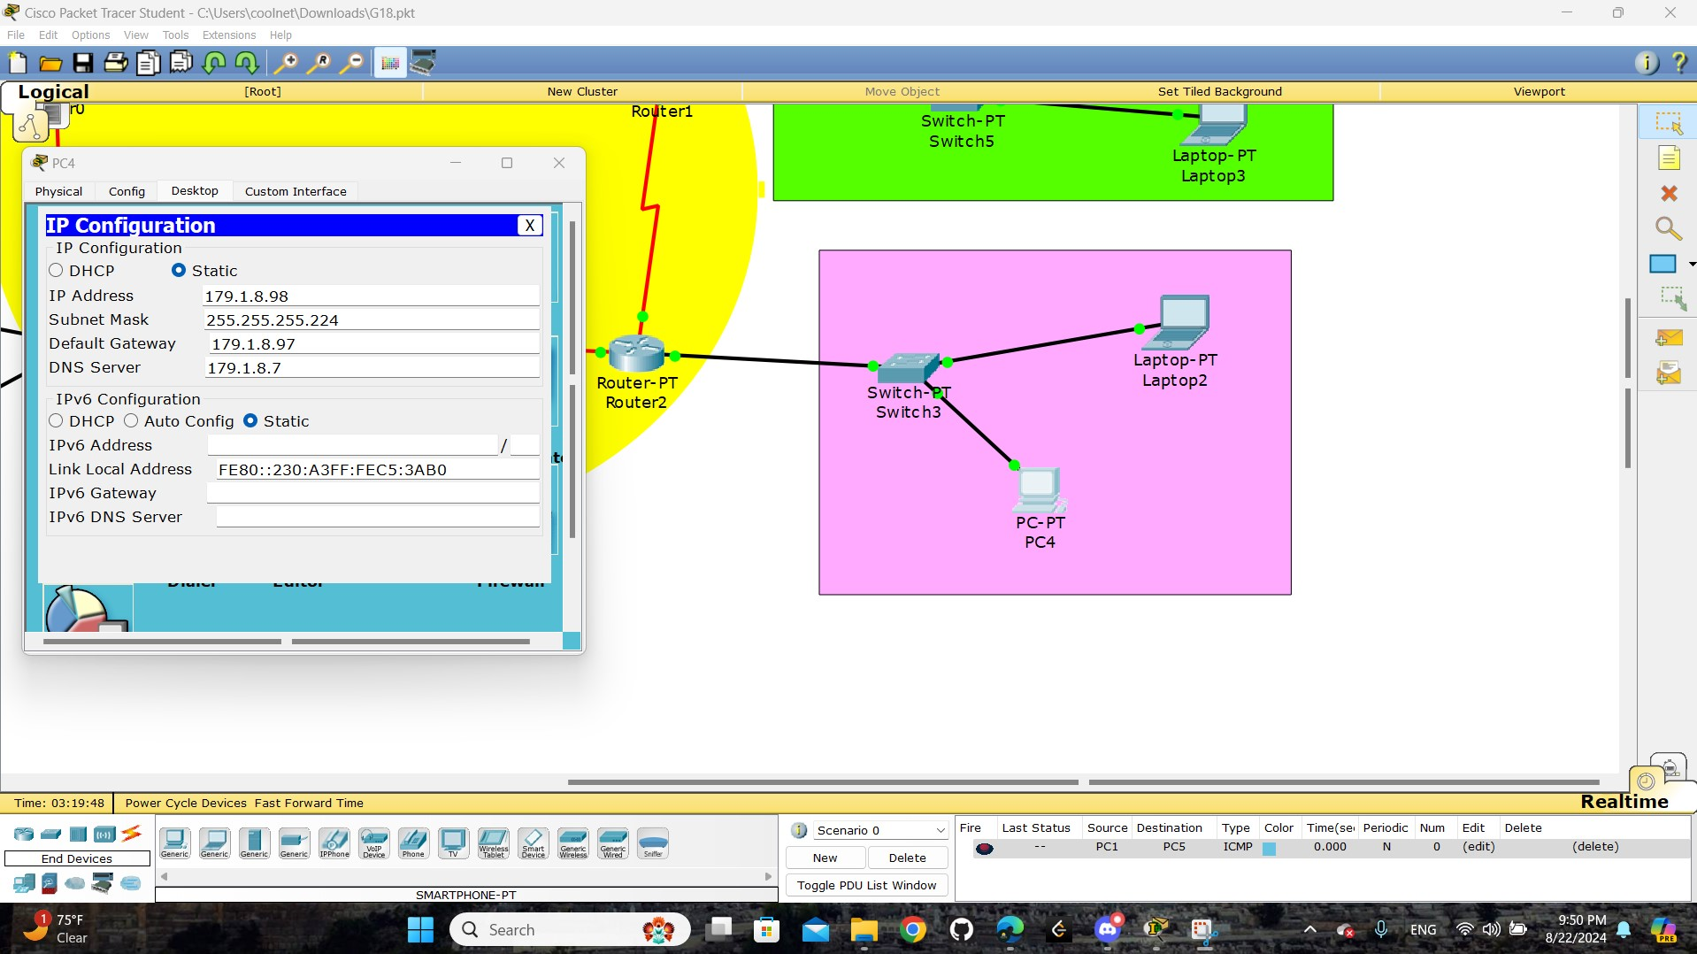

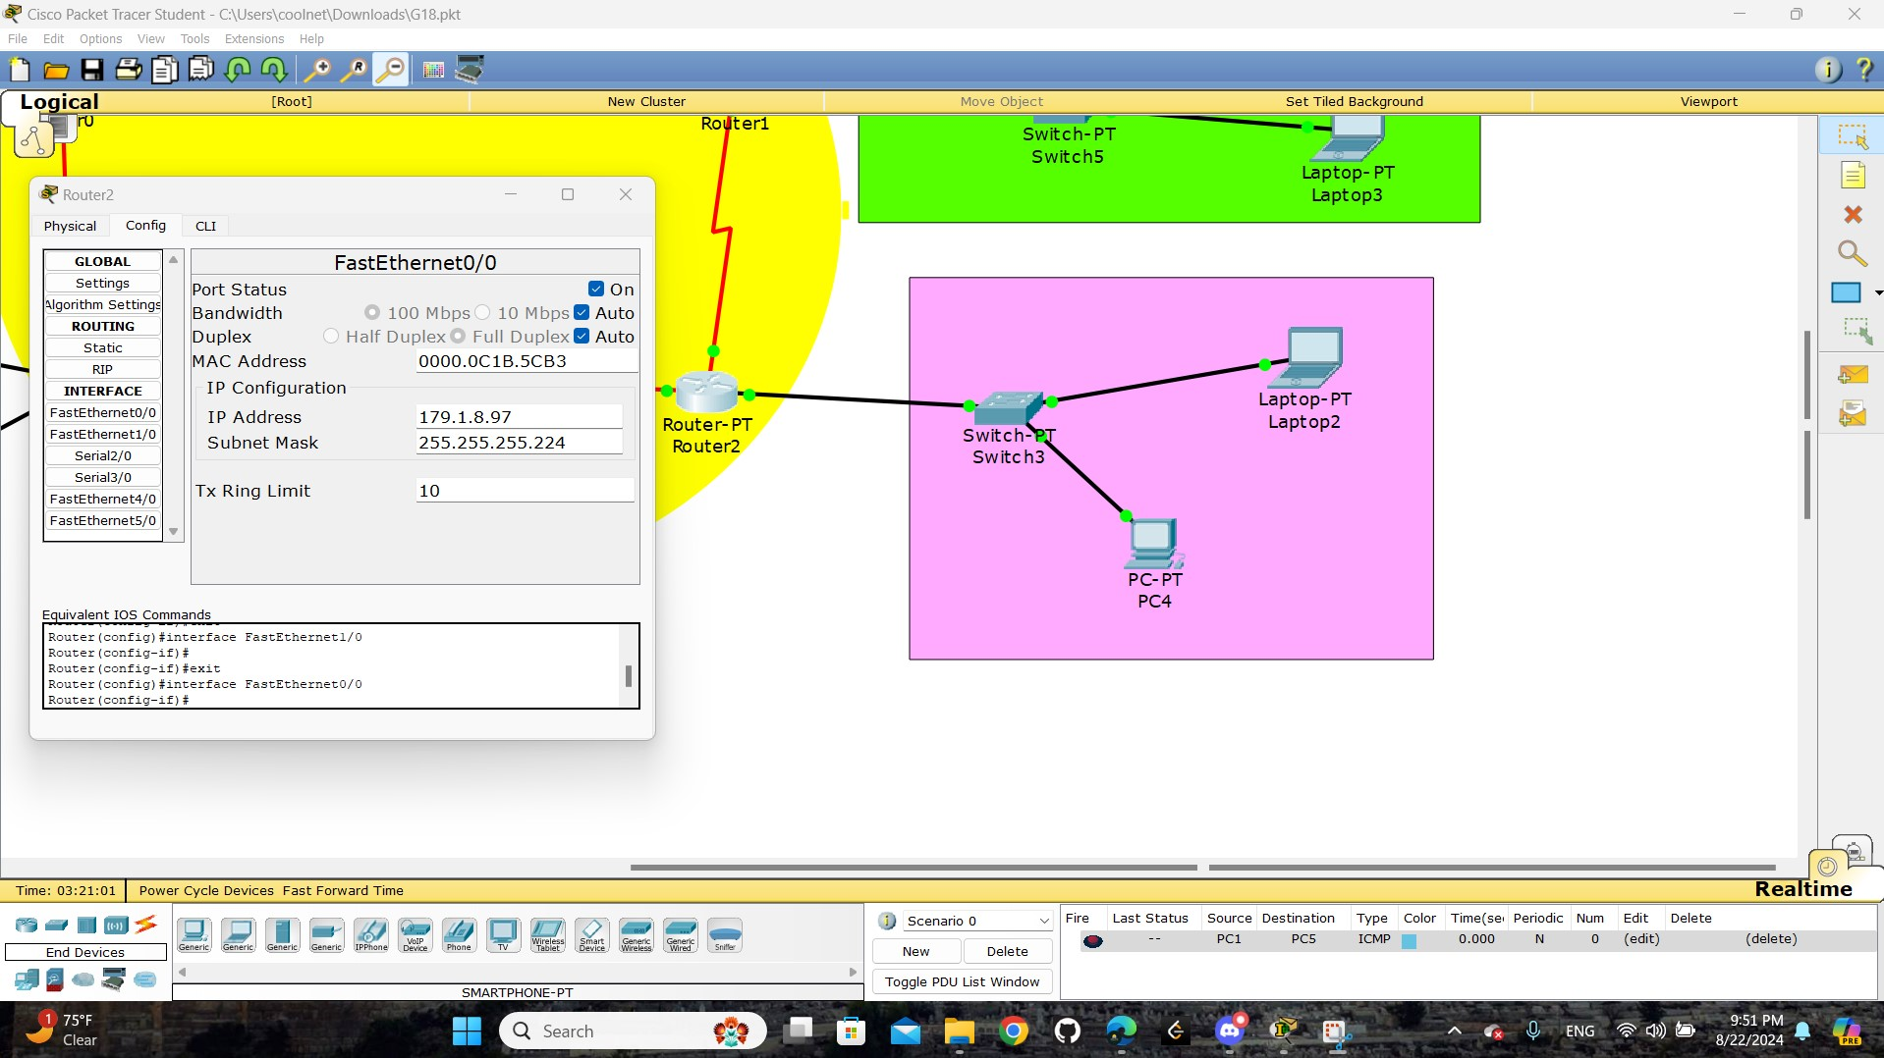

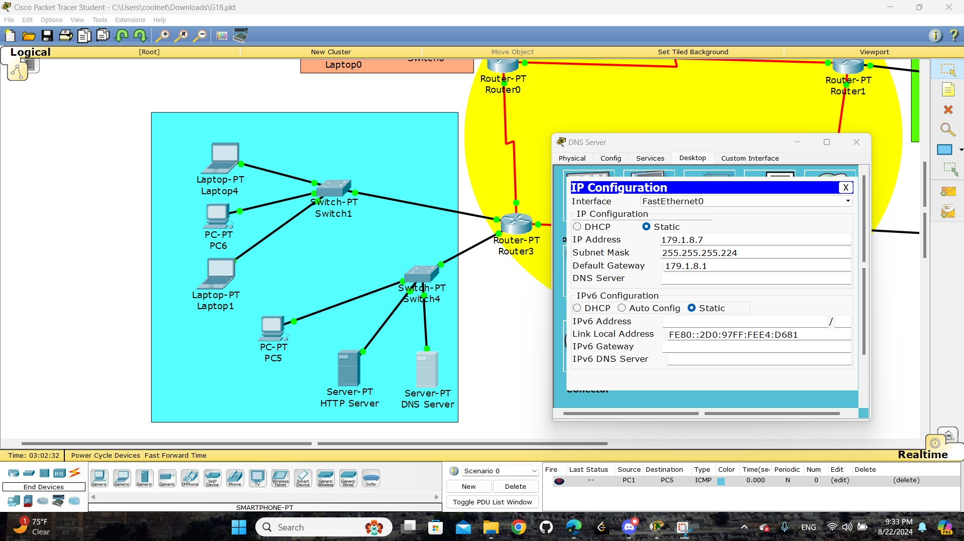

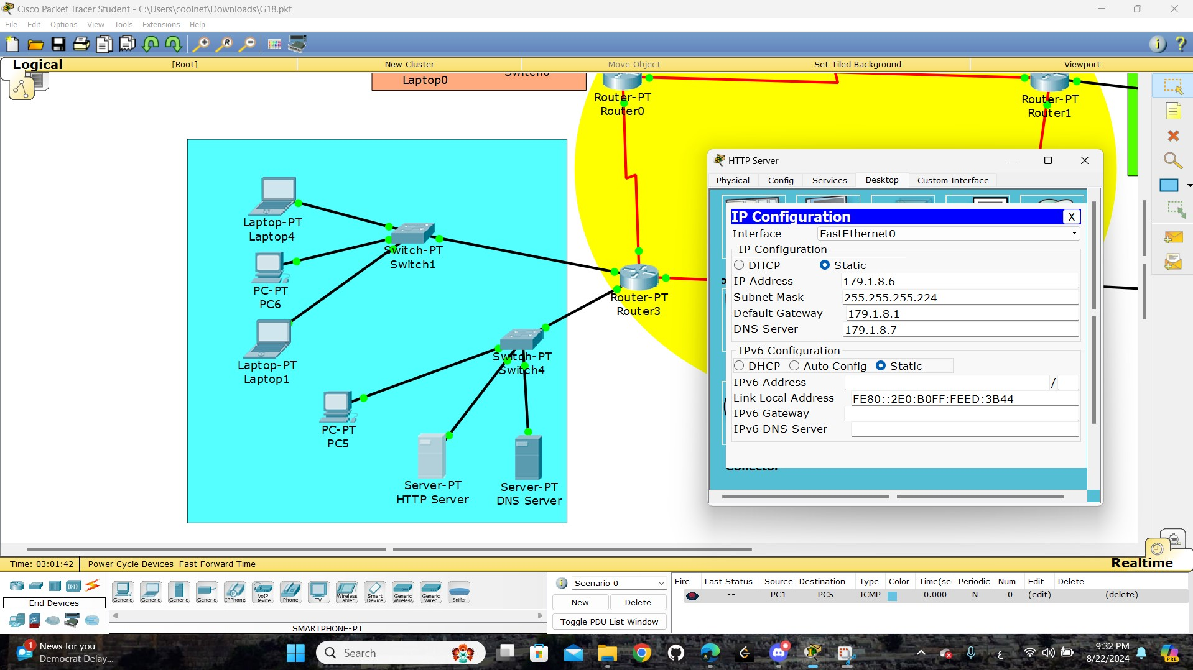

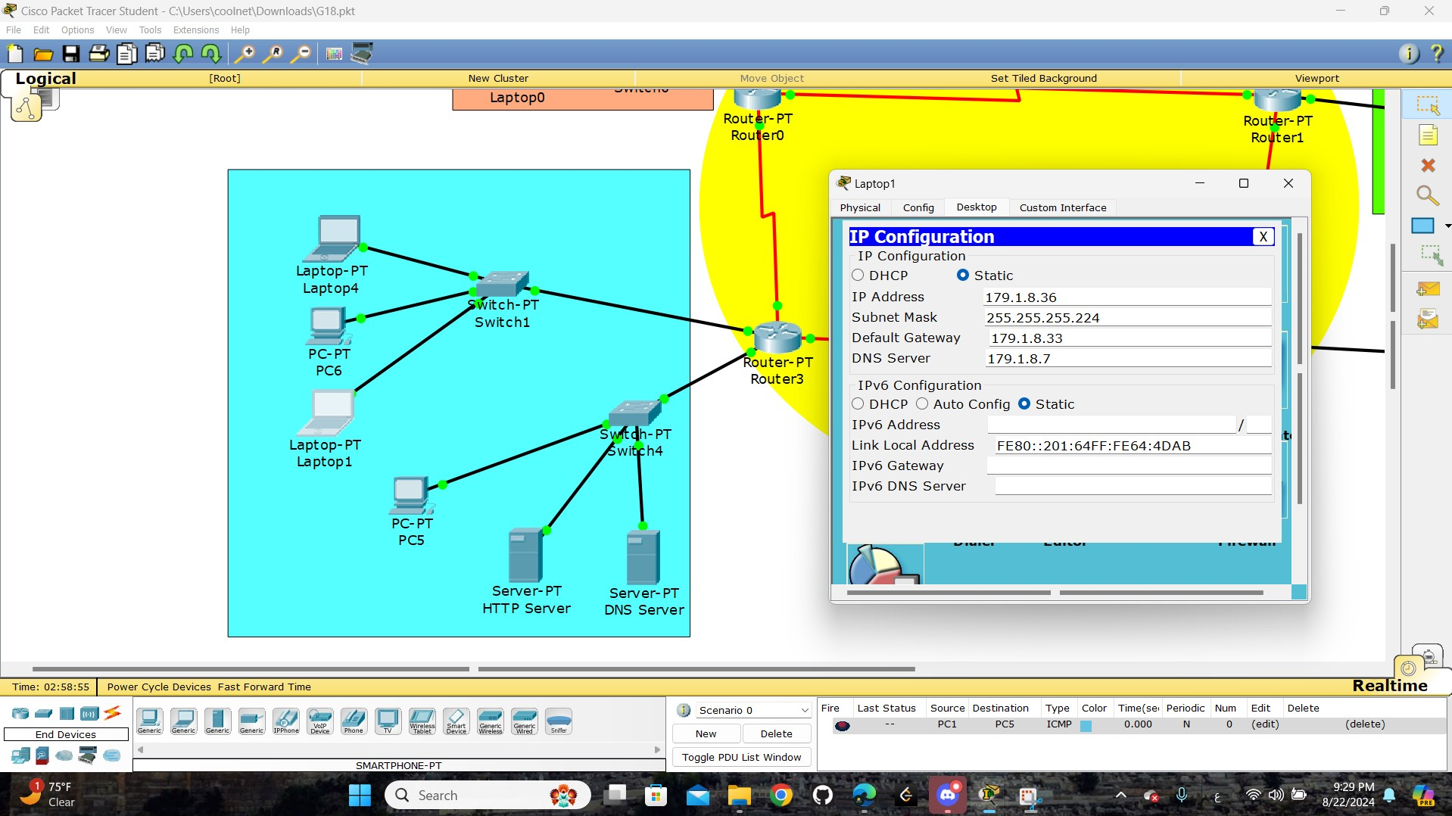

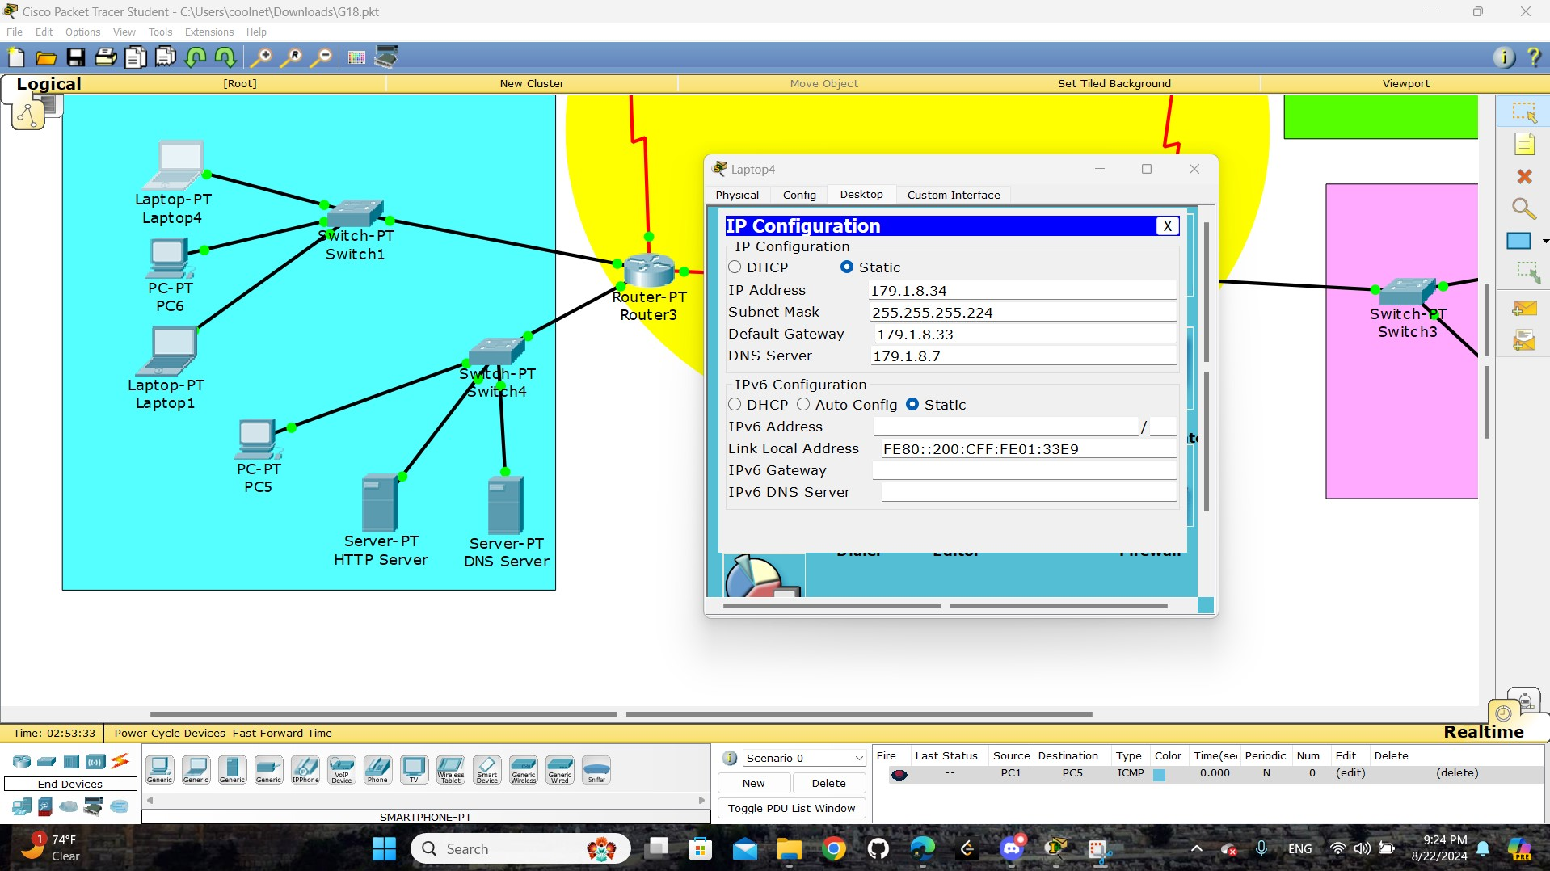

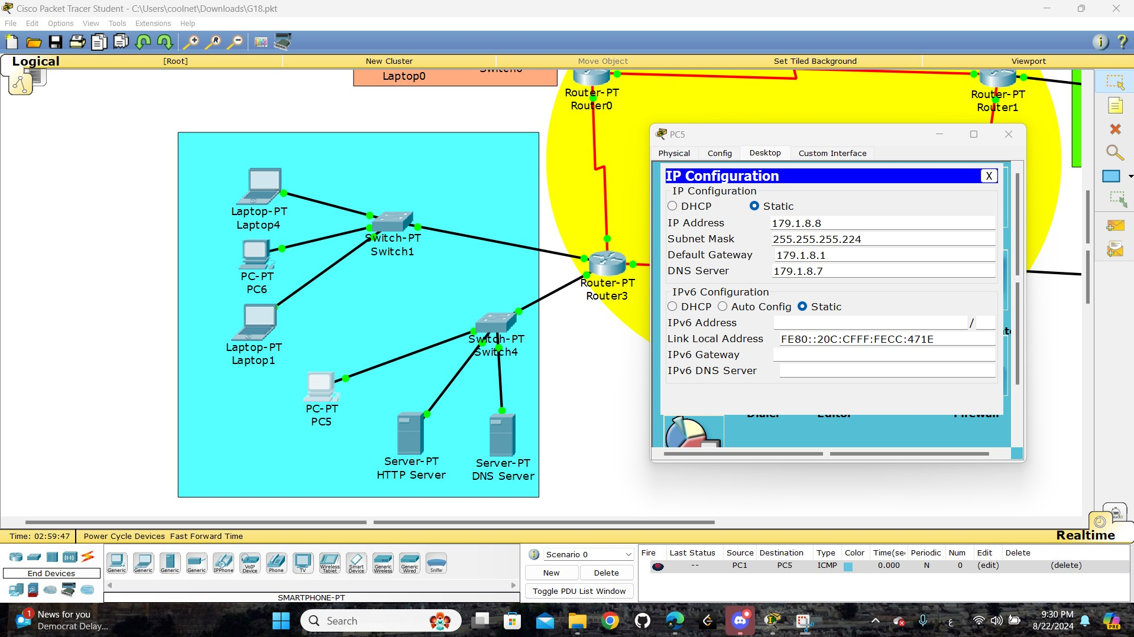

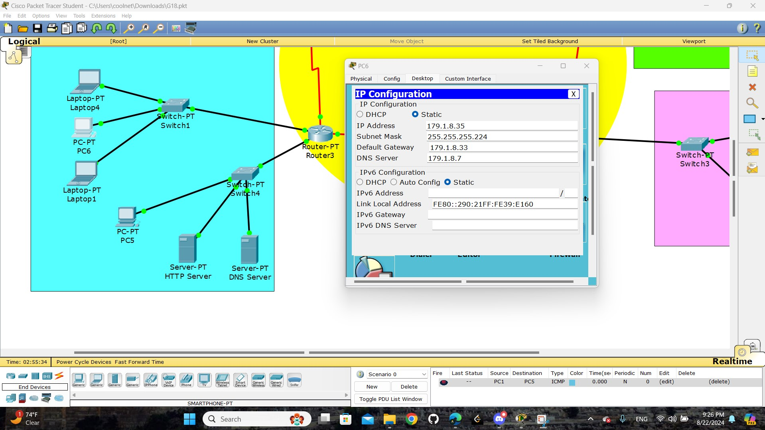

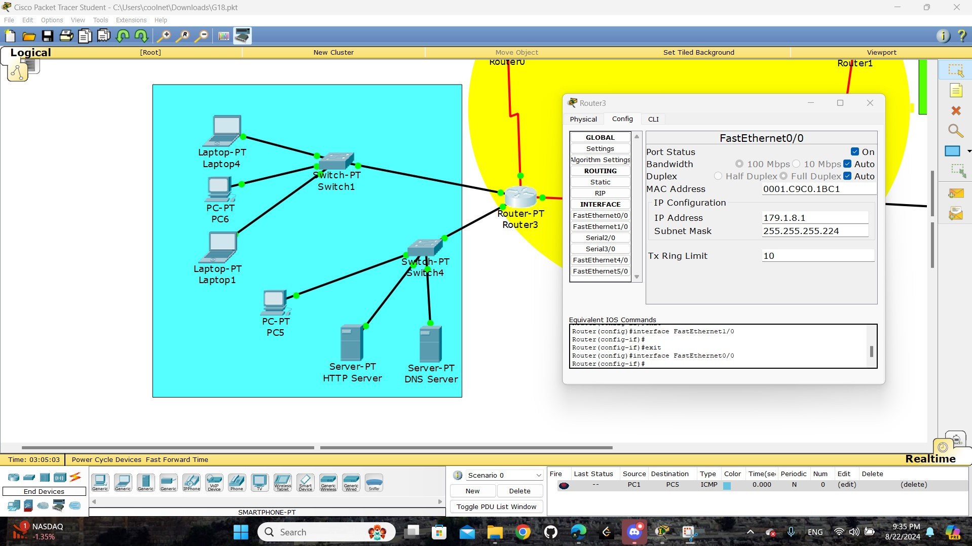

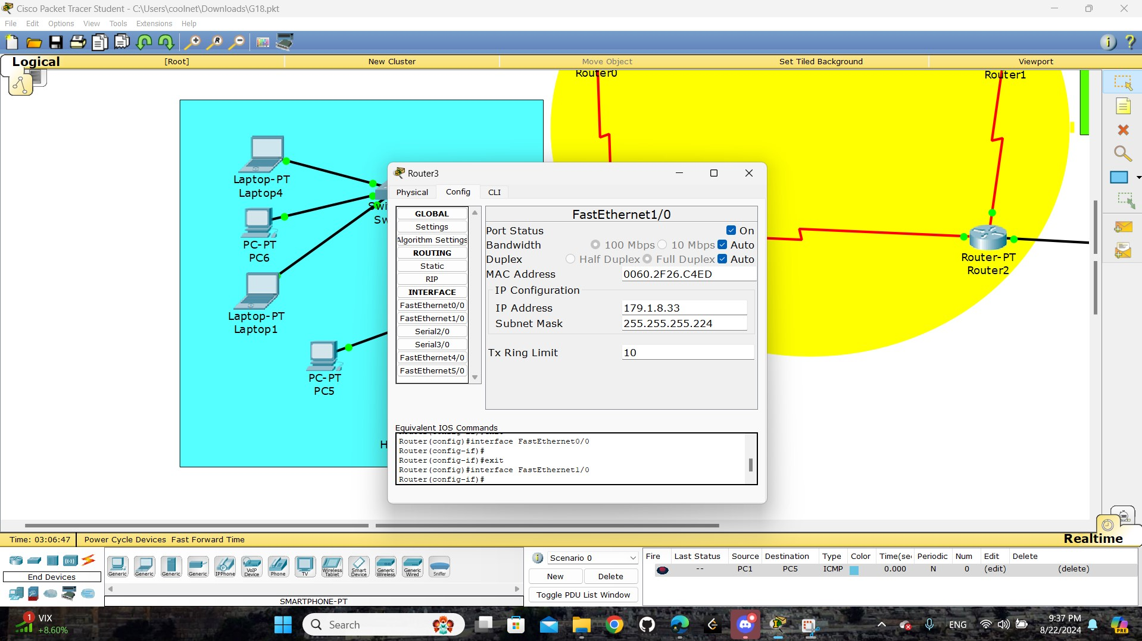

These images are to display the details of each device on the network and these details are

“ IP Configuration, IP Address, Subnet Mask, Default Gateway, DNS Server “.

# Task 1:

## Part1:

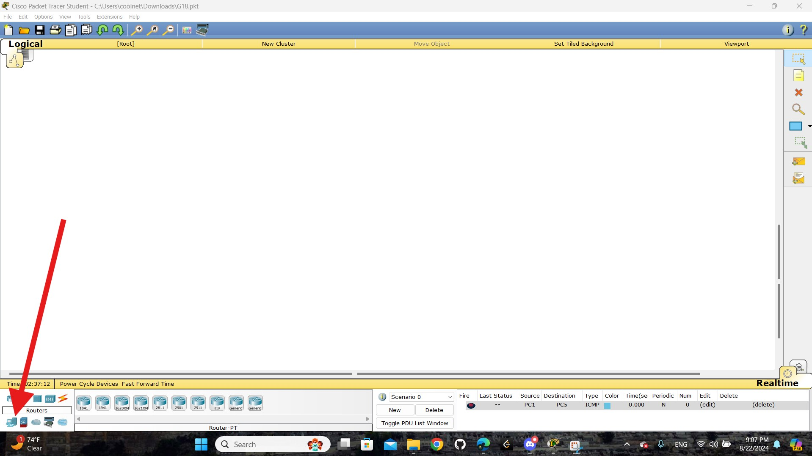

open ( end device ) tap

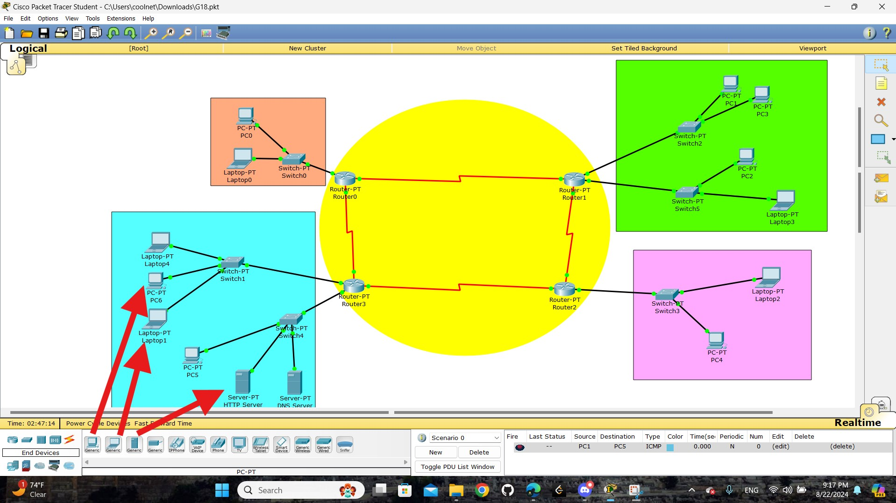

select any ( end device ) and put it where are you want









































how we set IP Addresses:

- Click on a device.

- Go to the **Desktop** tab, select **IP Configuration**.

- Enter the IP address, subnet mask, and gateway.

## Part2:

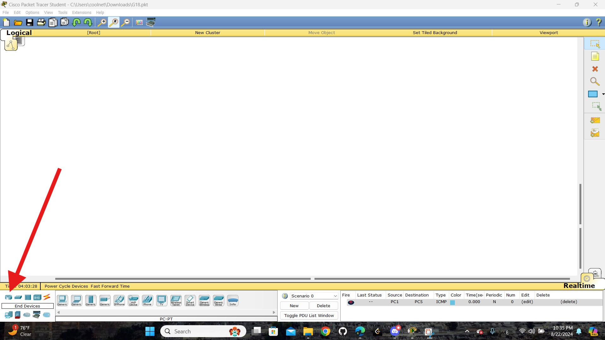

open ( router ) tap

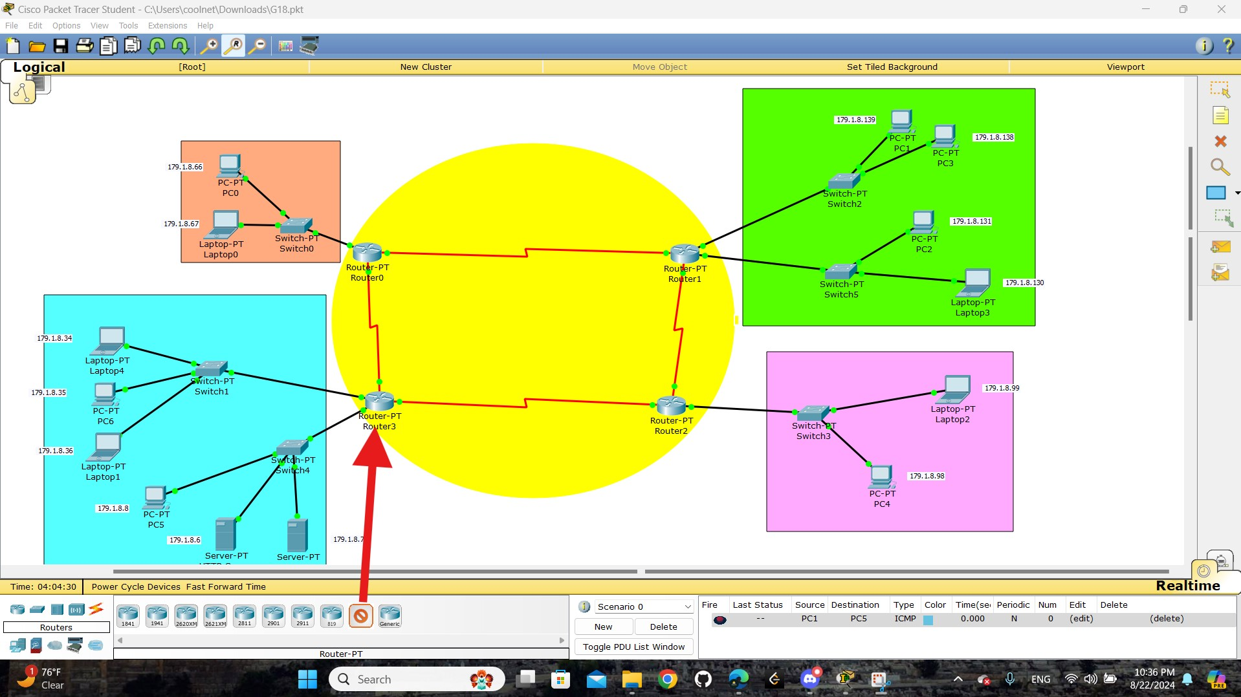

select general ( router ) and put it where are you want

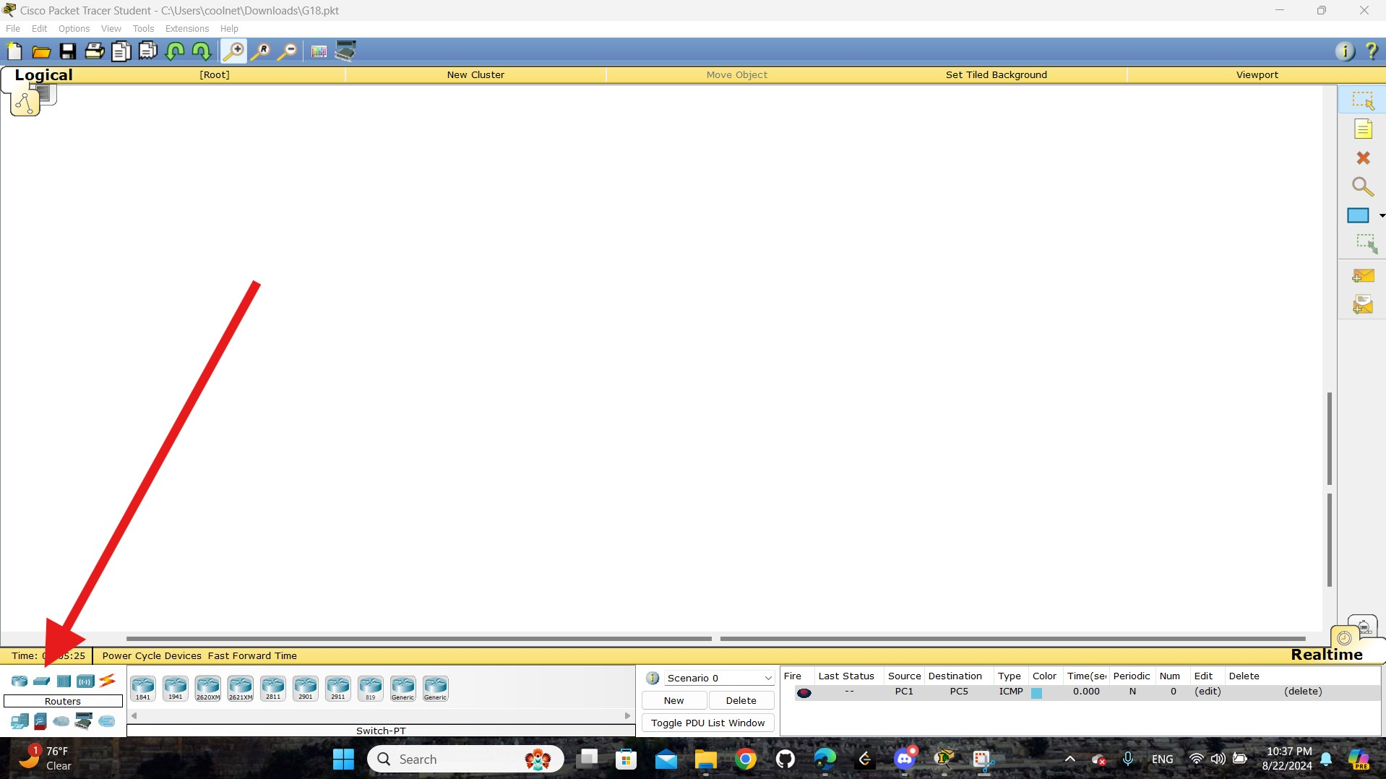

open ( switch) tap

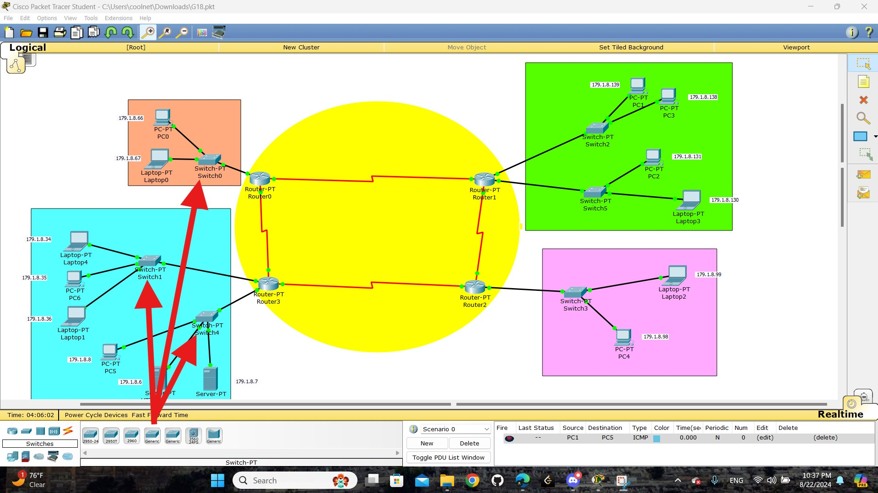

select general ( switch ) and put it where are you want

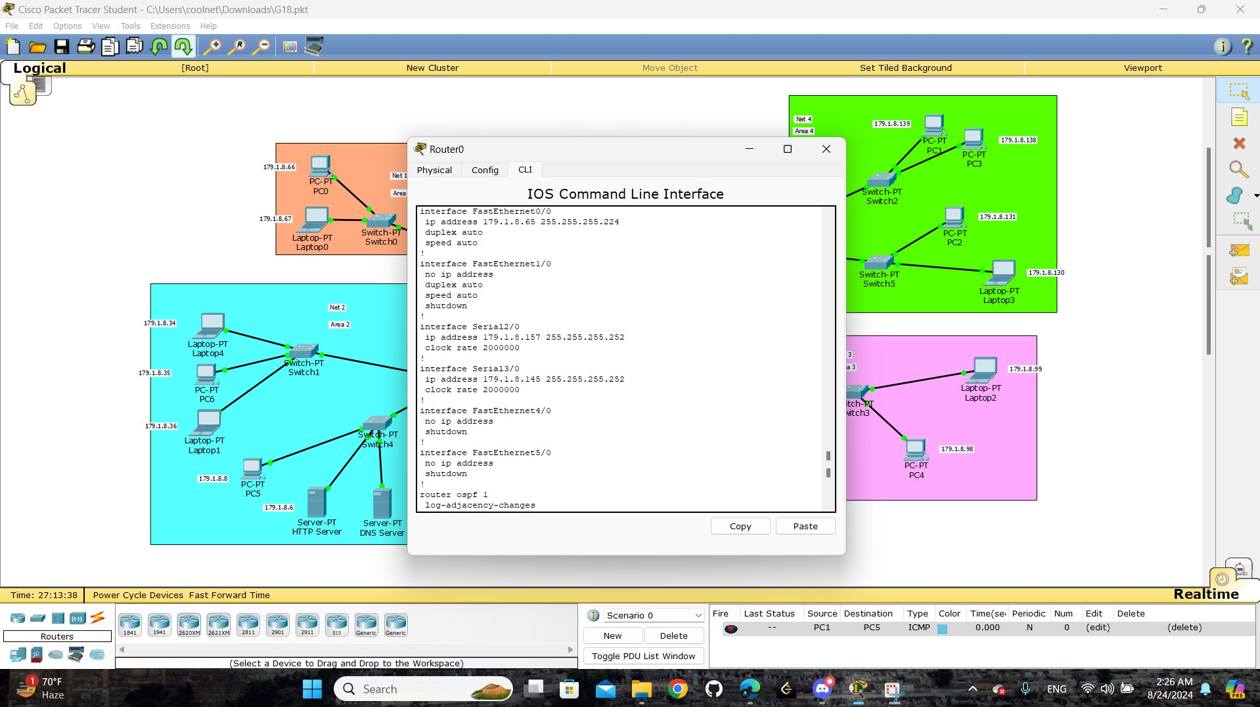

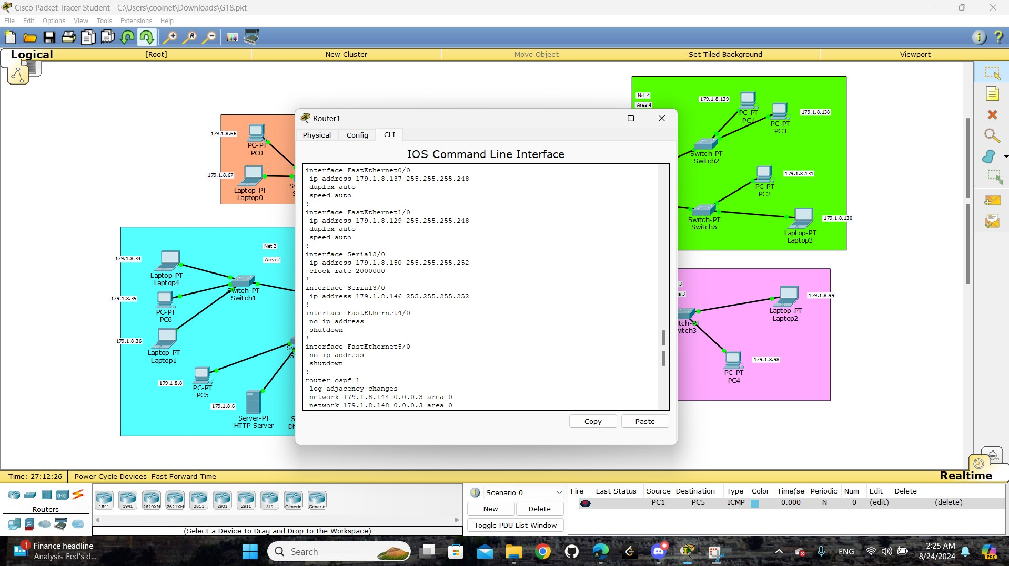

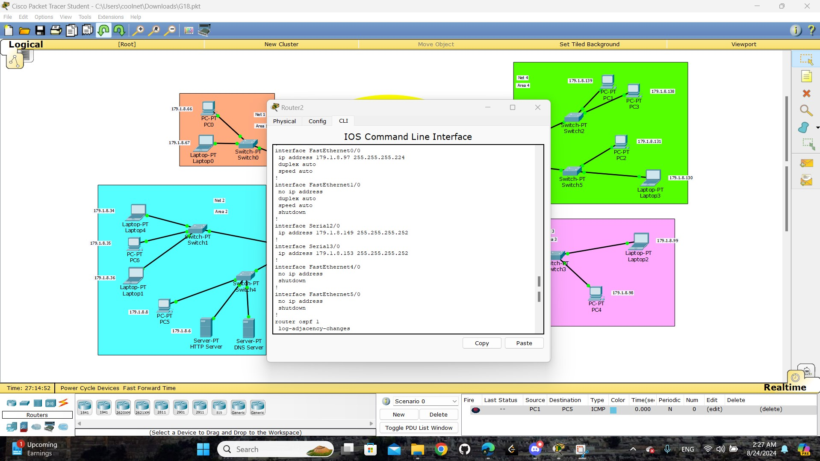

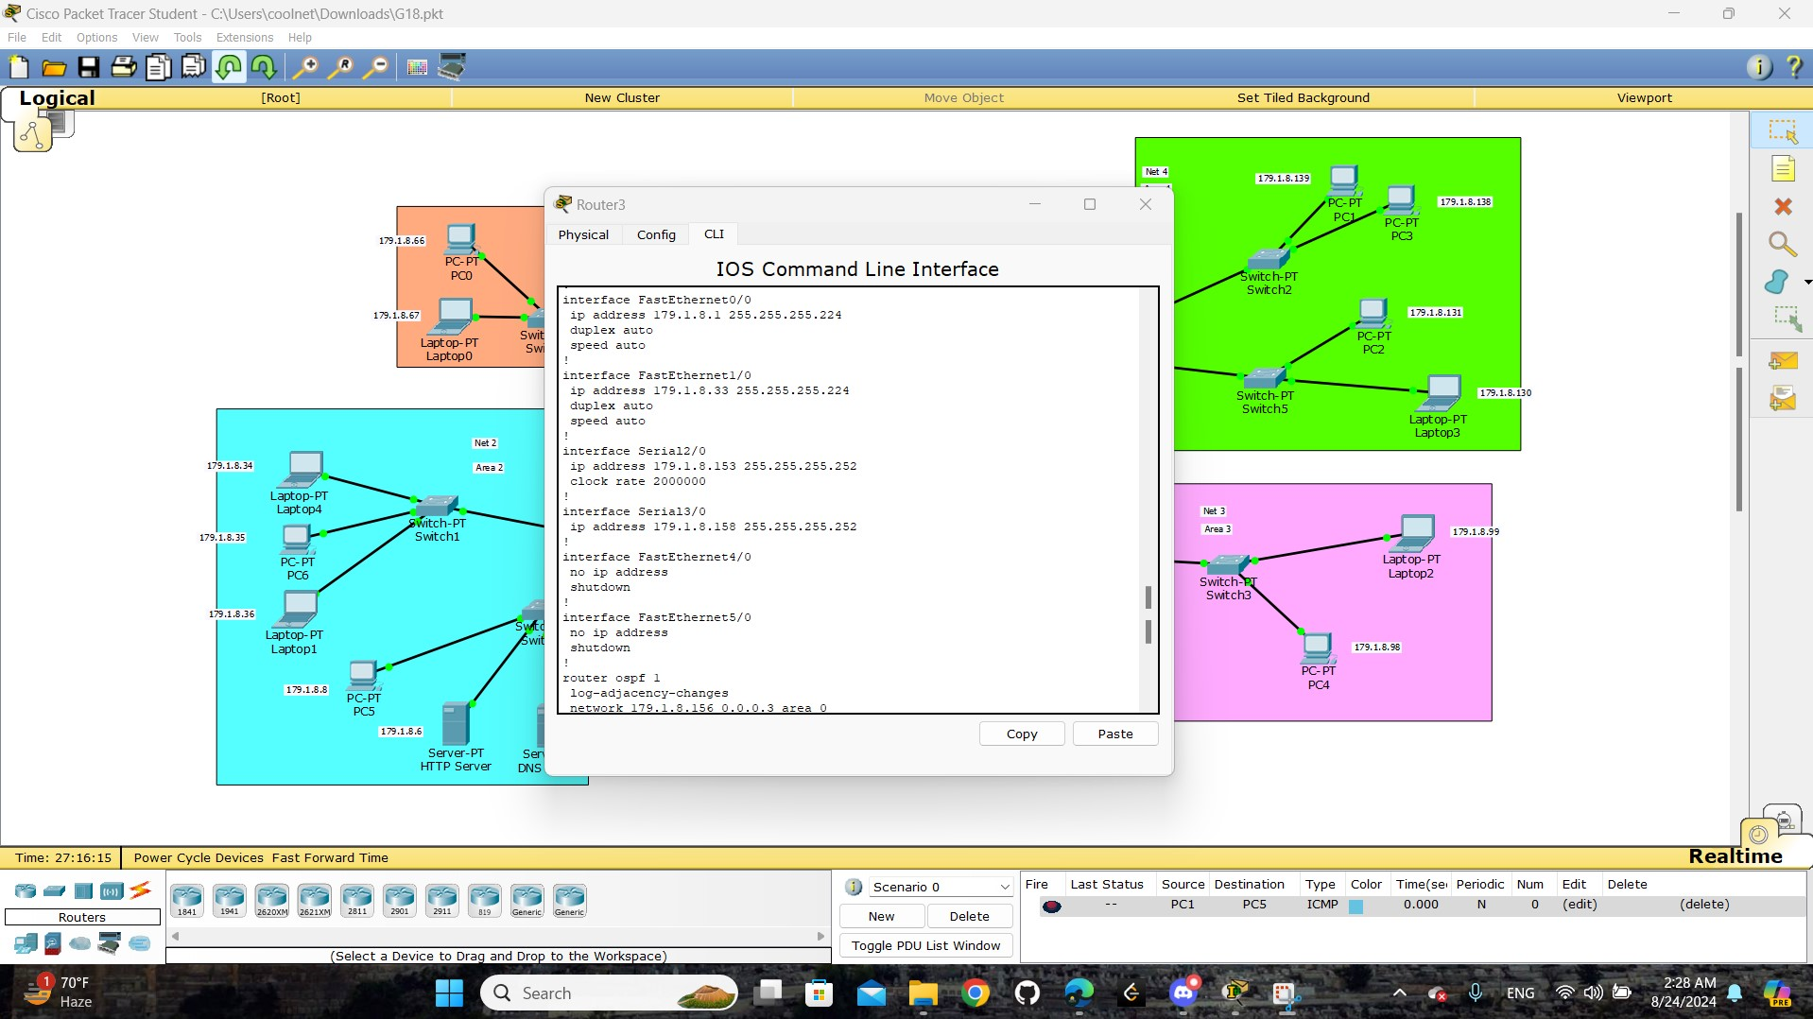

The images show the configuration of a router in Packet Tracer. The router's interfaces are set up with specific IP addresses: **ex:** “ `FastEthernet0/0` with `179.1.8.97/27` and `Serial2/0` with `179.1.8.149/30` “. The `no shutdown` command is used to activate them. Additionally, OSPF routing is configured to manage the network, with a command to log changes in OSPF neighbor relationships. This setup connects different network segments, enabling communication across them.

## Part3:

# 

This is a final image of the IP distribution on the devices.

# Task 2:

## part 1:

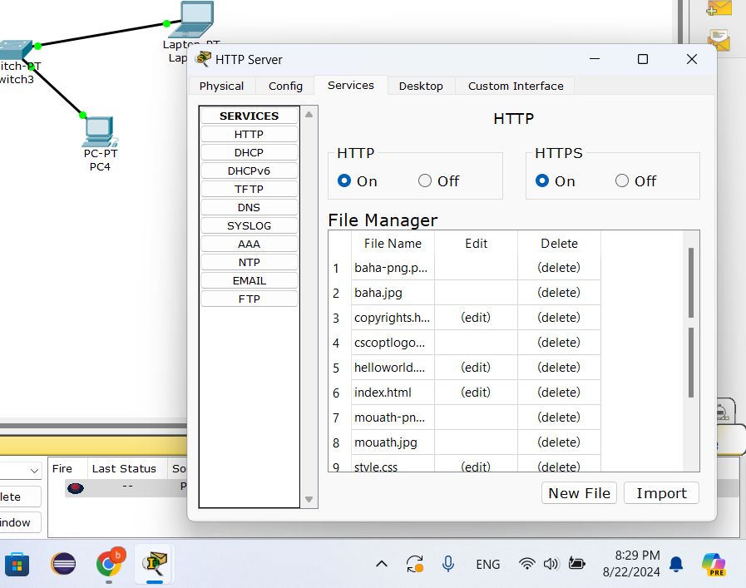

Here we have the HTTP server and it is on , and the file manager window shows a list of files and folders

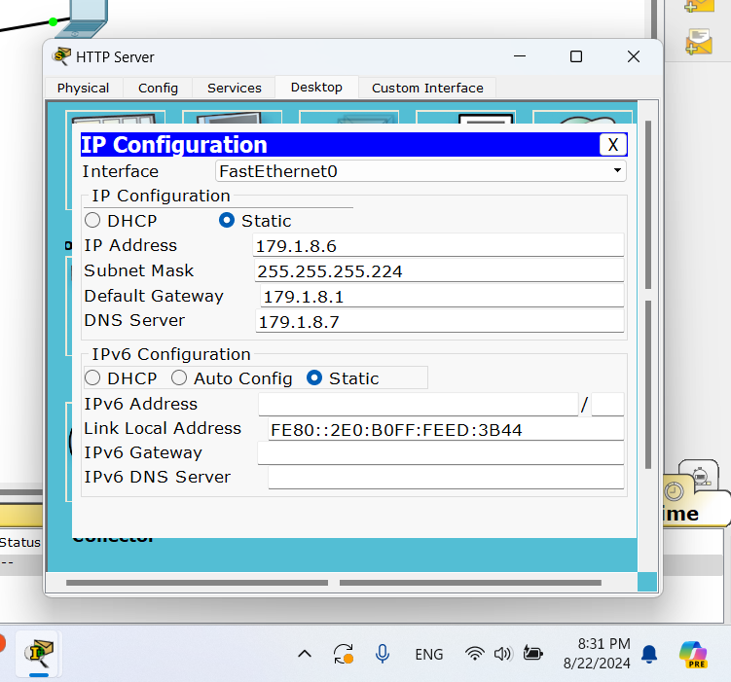

Here we have IP address , Subnet Mask , Default Gateway , DNS Server for HTTP server

## part 2:

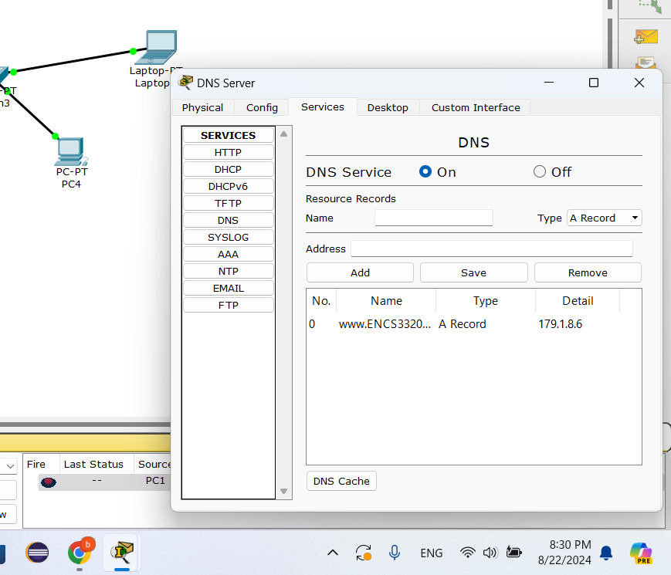

Here we have the DNS server and it is on , and we have the the domain name www.ENCS3320Summer.com

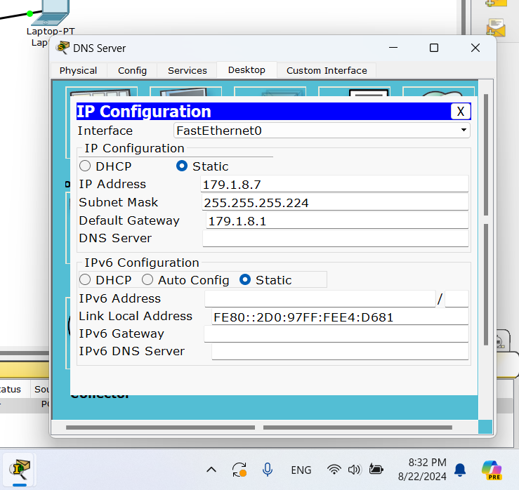

Here we have IP Address , Subnet Mask , Default Gateway for DNS server

## Part 3:

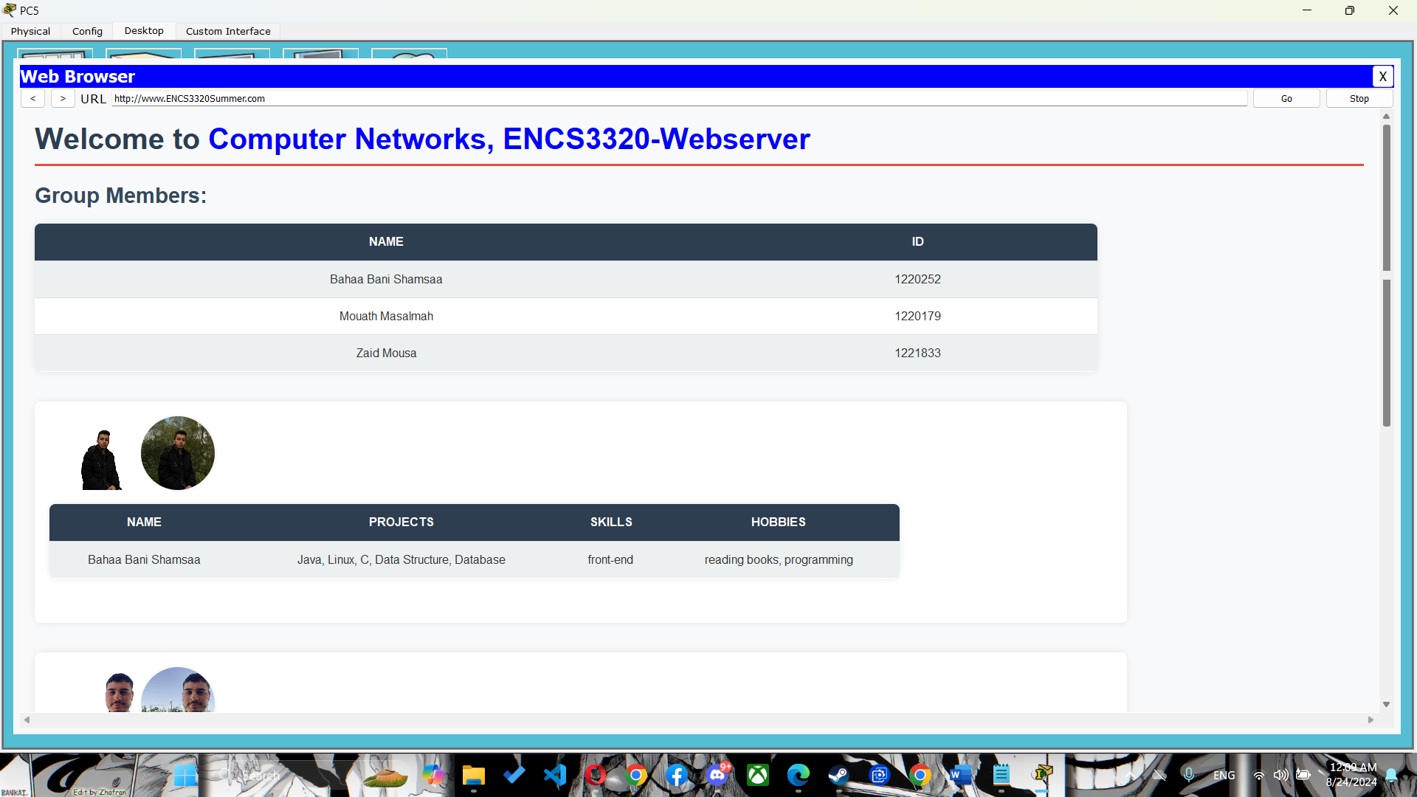

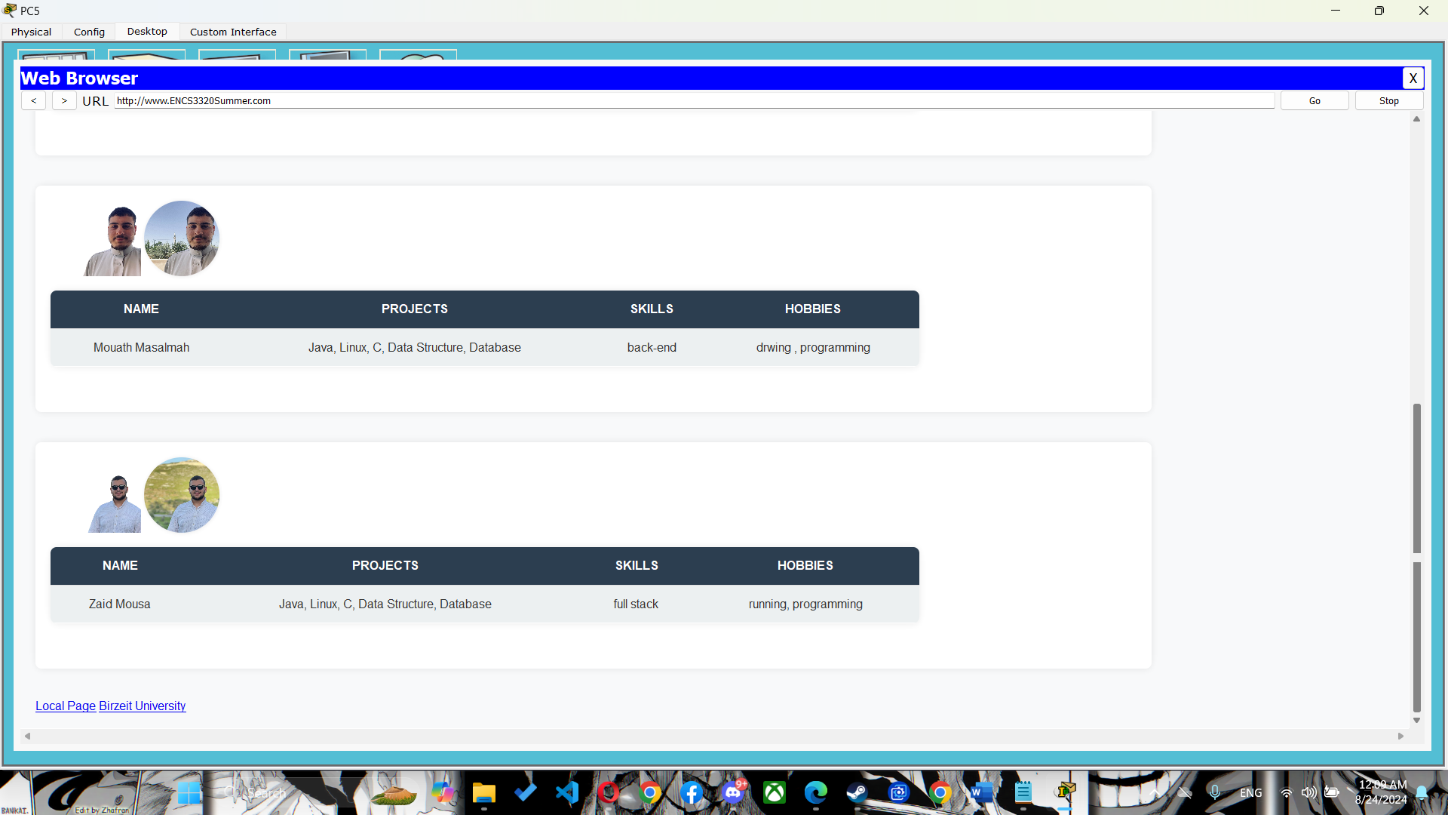

# Task 3:

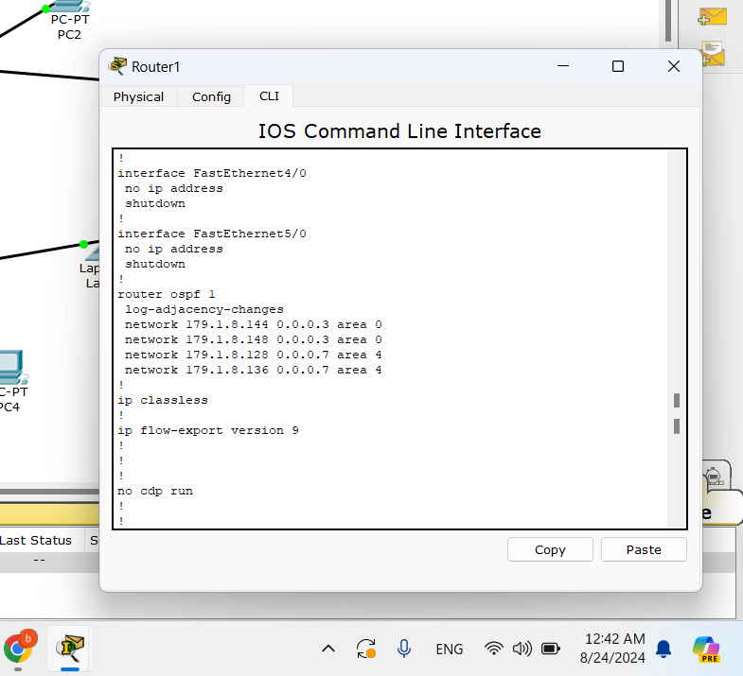

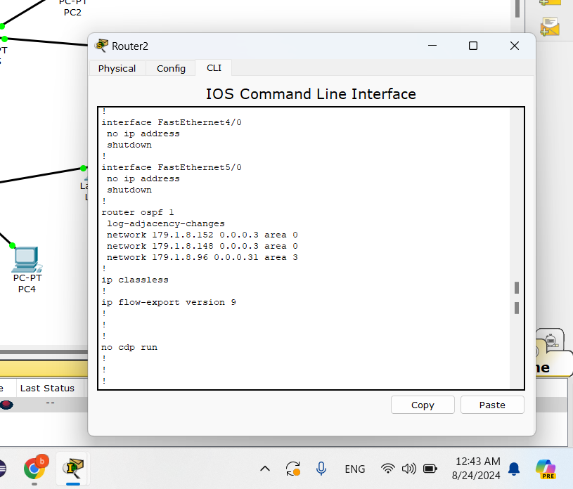

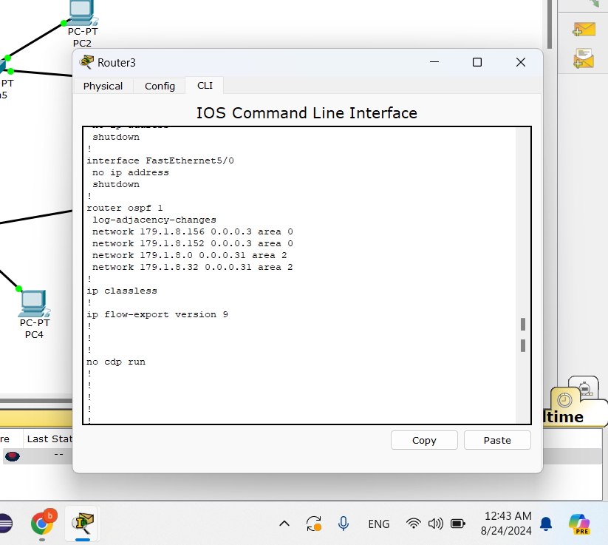

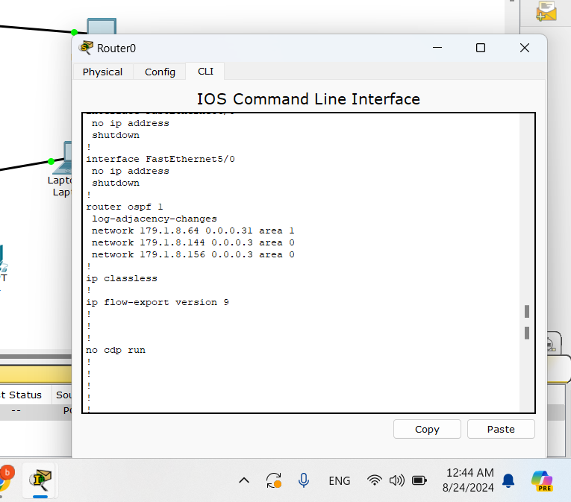

Open Shortest Path First (OSPF) is a routing protocol that helps routers find the best path to send data. It's smart, fast, and works well in large networks.

To use OSPF:

**Start OSPF:**

* Go to the router’s configuration mode and start OSPF by giving it a number (process ID).

**Add Networks to OSPF:**

* Tell OSPF which networks to manage and in which area they belong.

**(Optional) Set Router ID:**

* Assign a unique ID to your router to identify it in the network.

Commands:

router ospf 1

log-adjacency-changes

network 179.1.8.144 0.0.0.3 area 0

network 179.1.8.148 0.0.0.3 area 0

network 179.1.8.128 0.0.0.7 area 4

network 179.1.8.136 0.0.0.7 area 4

router ospf 1

log-adjacency-changes

network 179.1.8.152 0.0.0.3 area 0

network 179.1.8.148 0.0.0.3 area 0

network 179.1.8.96 0.0.0.31 area 3

router ospf 1

log-adjacency-changes

network 179.1.8.64 0.0.0.31 area 1

network 179.1.8.144 0.0.0.3 area 0

network 179.1.8.156 0.0.0.3 area 0

router ospf 1

log-adjacency-changes

network 179.1.8.156 0.0.0.3 area 0

network 179.1.8.152 0.0.0.3 area 0

network 179.1.8.0 0.0.0.31 area 2

network 179.1.8.32 0.0.0.31 area 2

# Task 4:

## part 1:

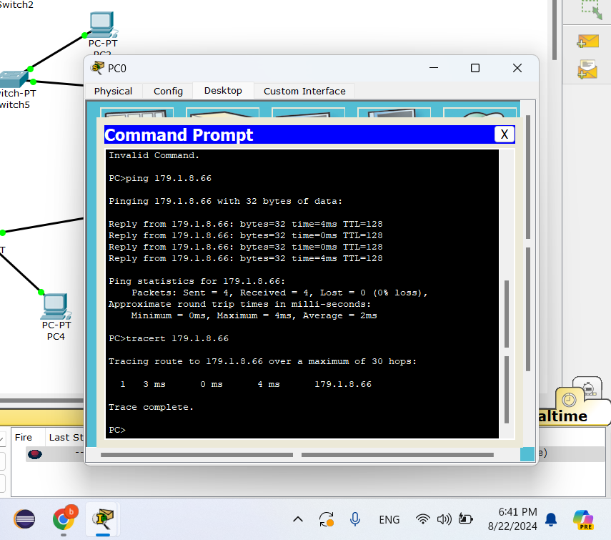

Tracert and ping for PC0 with ip 179.1.8.66 and it works as shown in picture

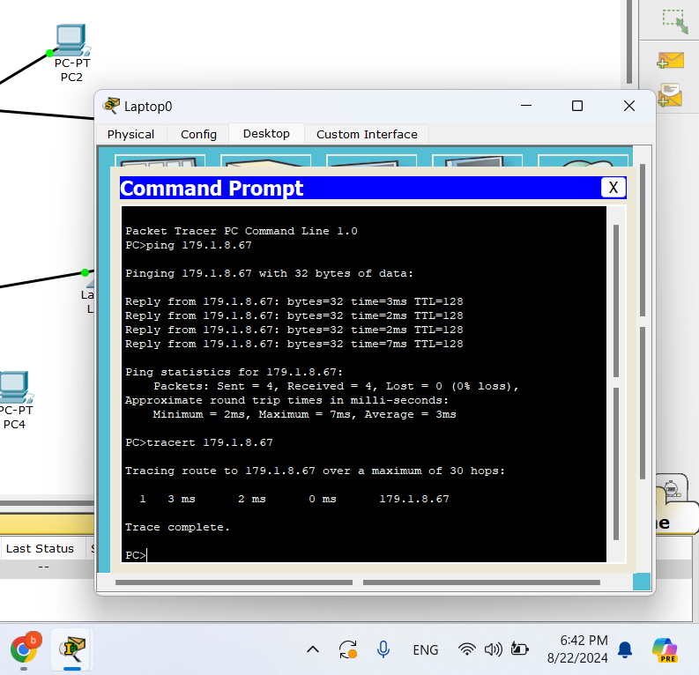

Tracert and ping for Laptop0 with ip 179.1.8.67 and it works as shown in picture

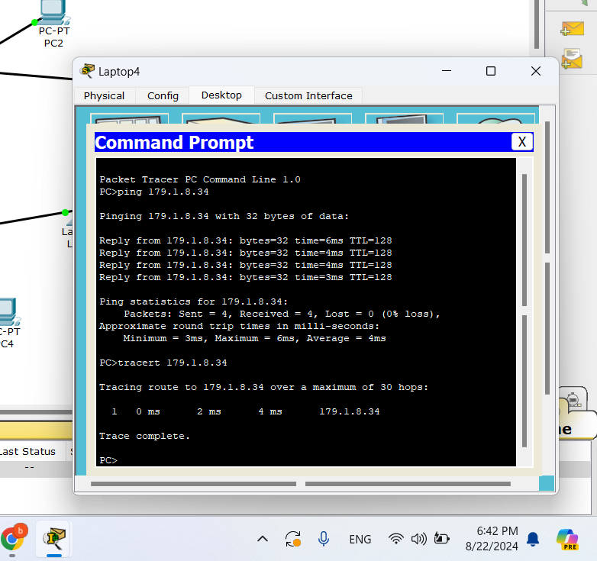

Tracert and ping for Laptop4 with ip 179.1.8.34 and it works as shown in picture

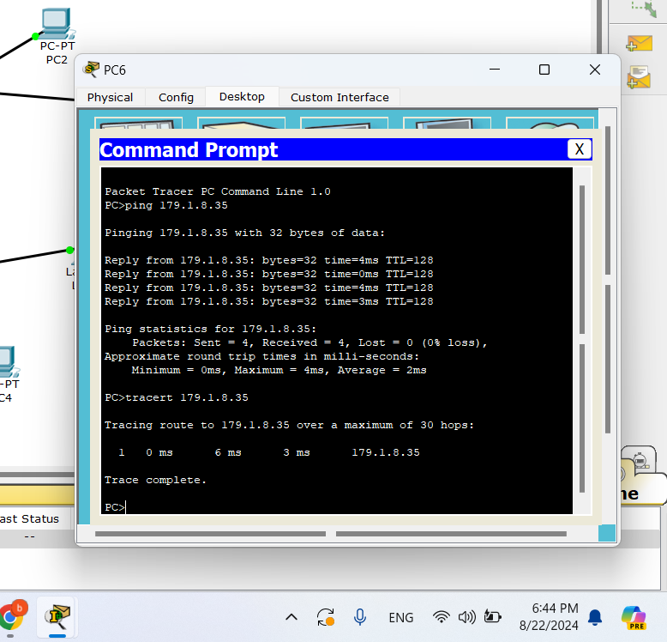

Tracert and ping for PC6 with ip 179.1.8.35 and it works as shown in picture

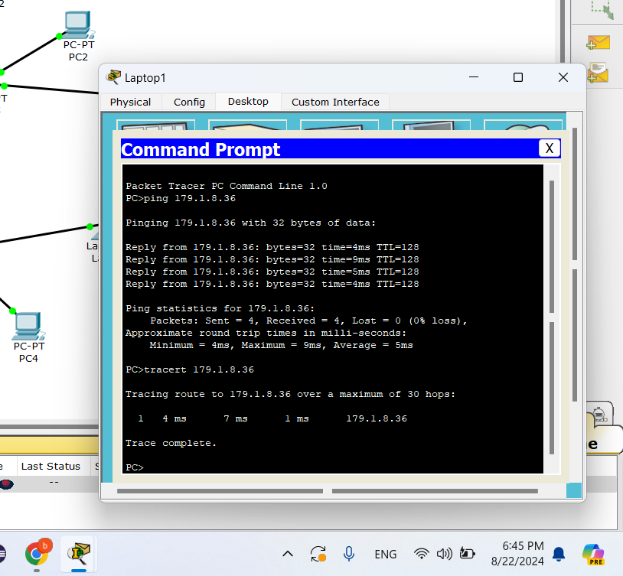

Tracert and ping for Laptop1 with ip 179.1.8.36 and it works as shown in picture

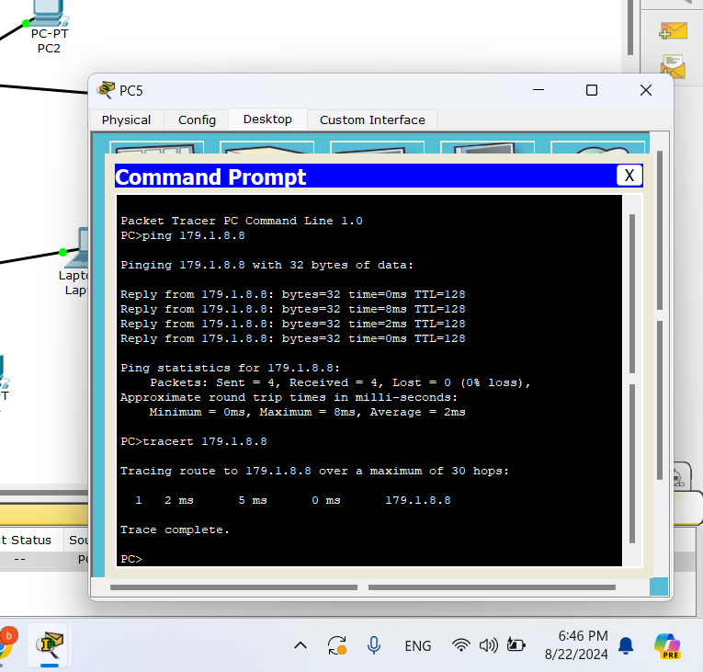

Tracert and ping for PC5 with ip 179.1.8.8 and it works as shown in picture

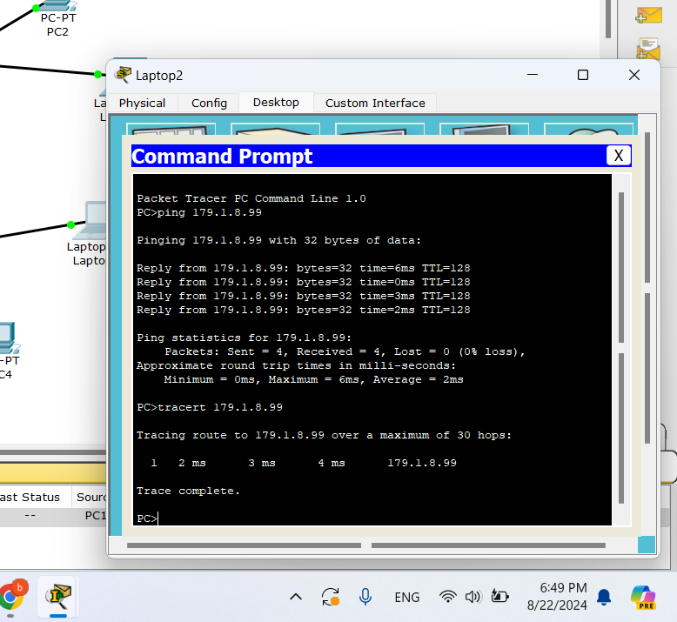

Tracert and ping for Laptop2 with ip 179.1.8.99 and it works as shown in picture

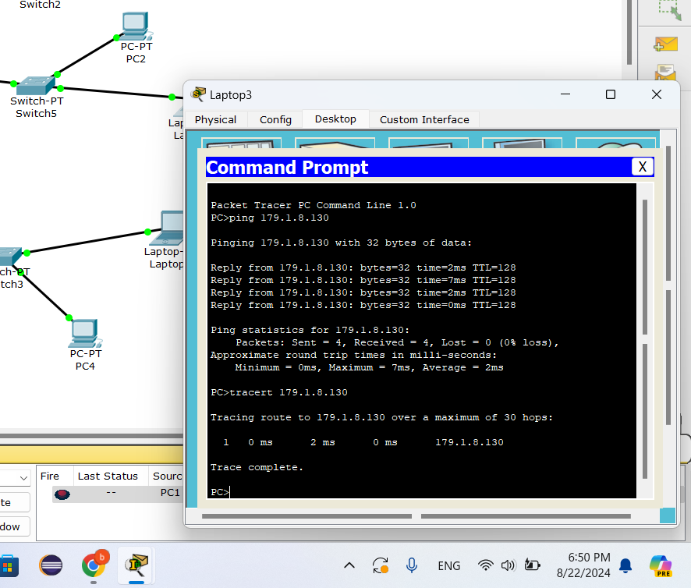

Tracert and ping for Laptop3 with ip 179.1.8.130 and it works as shown in picture



Tracert and ping for Laptop3 with ip 179.1.8.130 and it works as shown in picture

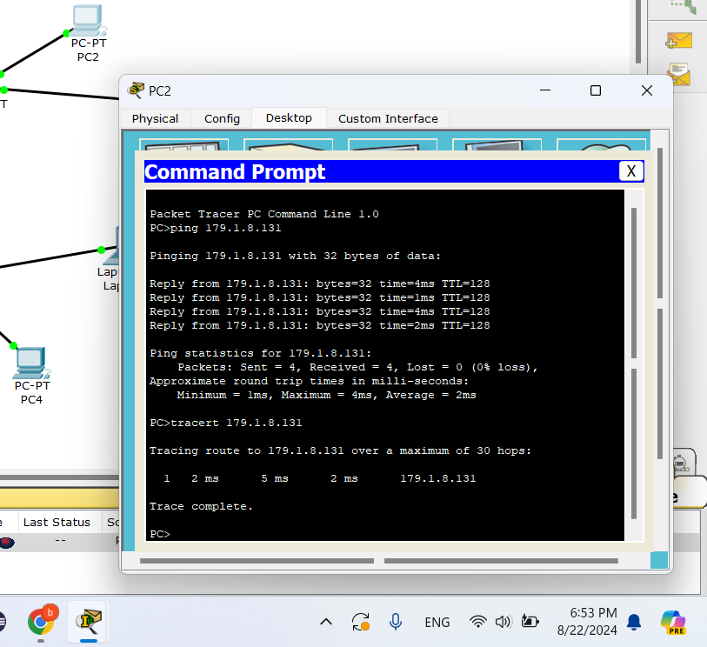

Tracert and ping for PC2 with ip 179.1.8.131 and it works as shown in picture

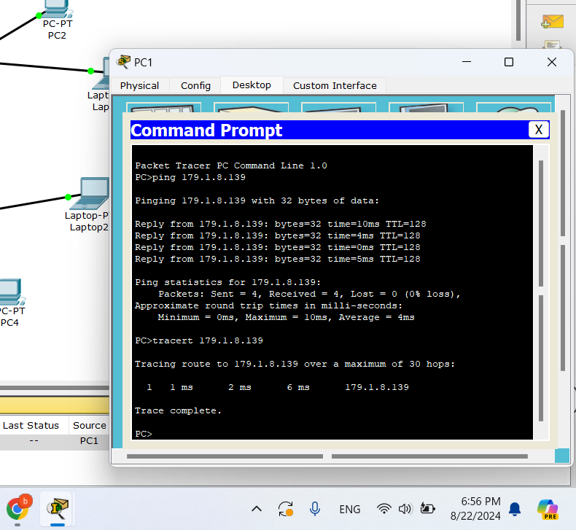

Tracert and ping for PC1 with ip 179.1.8.139 and it works as shown in picture

## 

## 

## part 2:

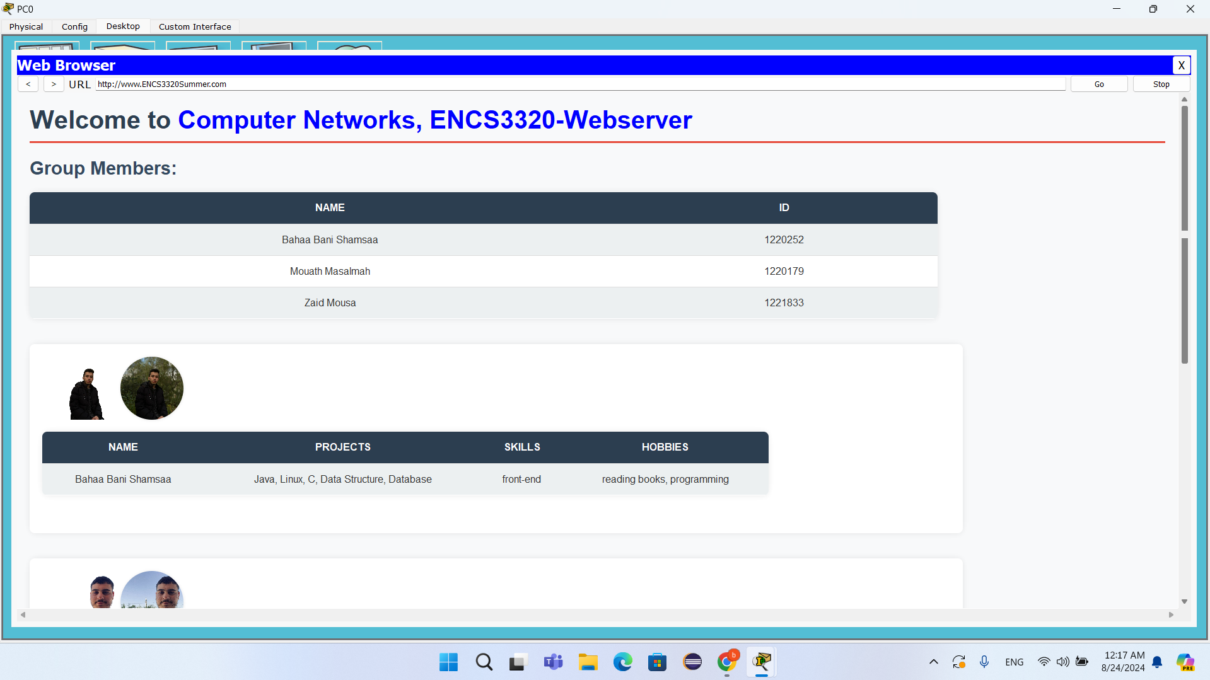

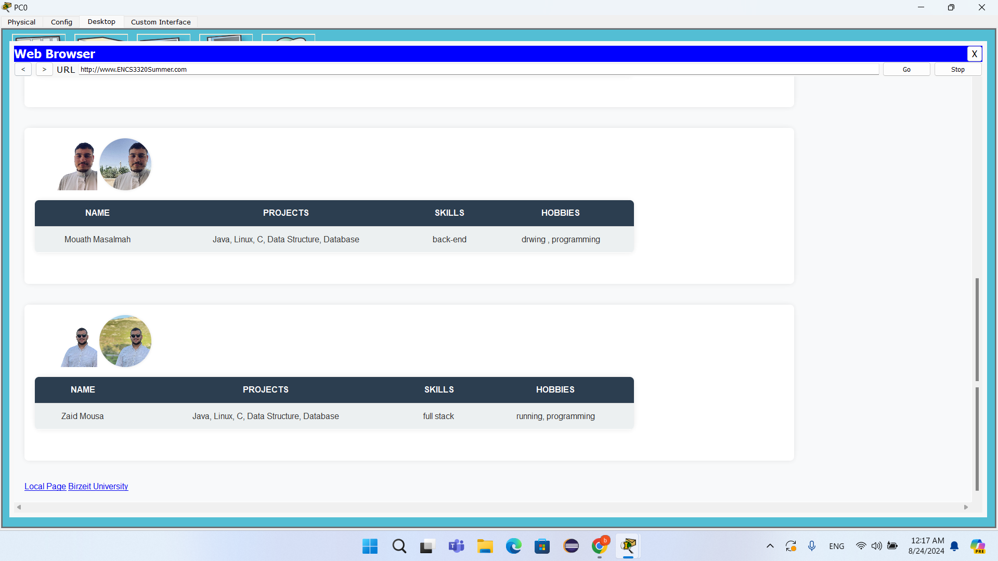

web page for PC0

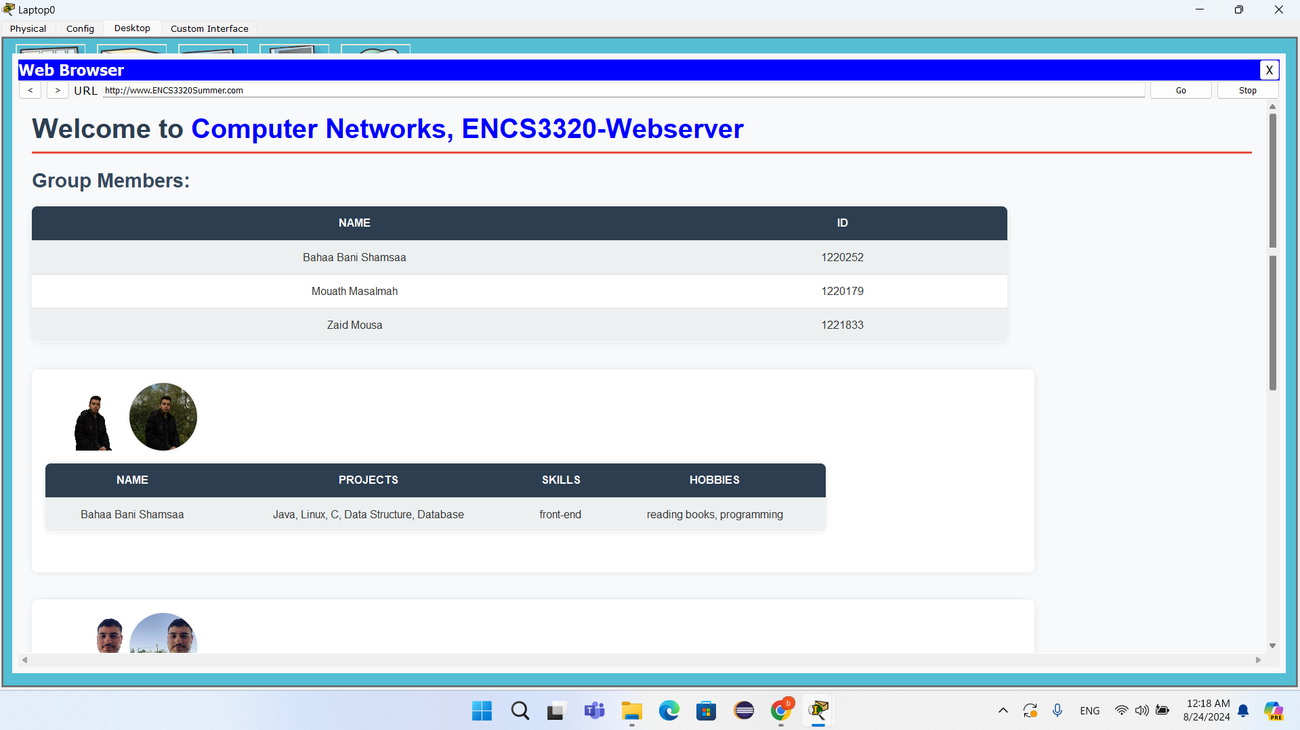

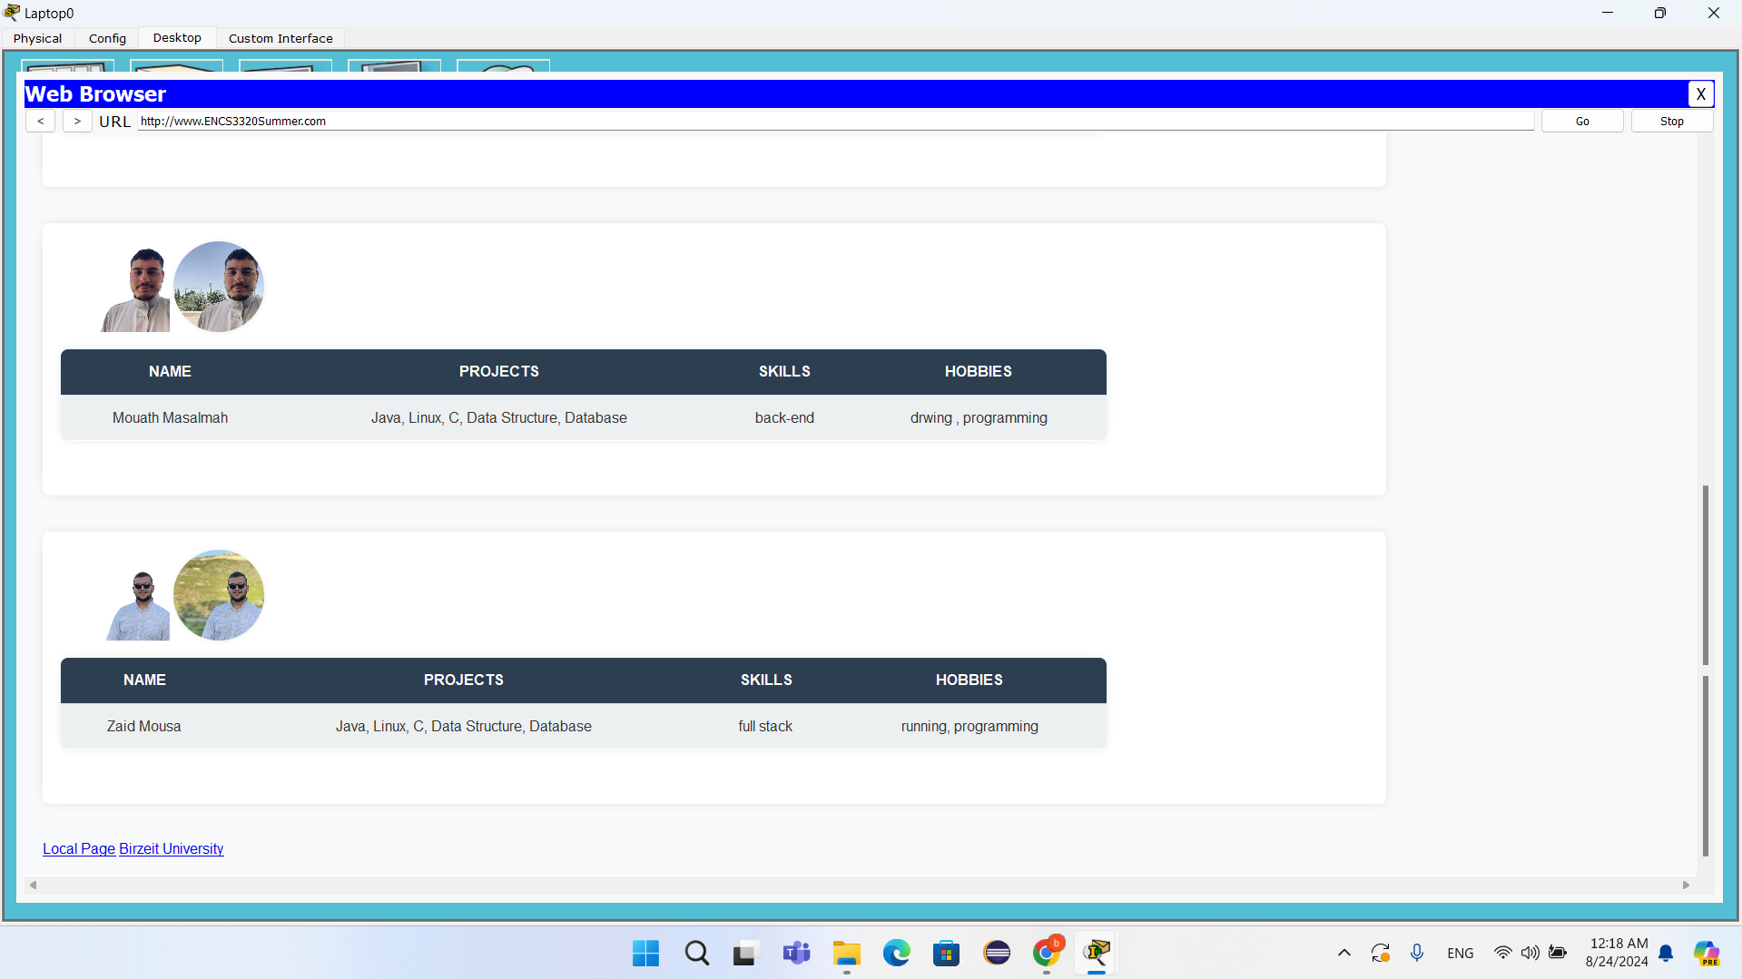

web page for Laptop0

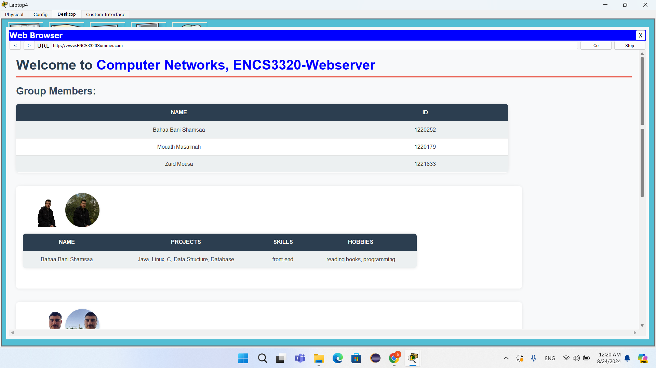

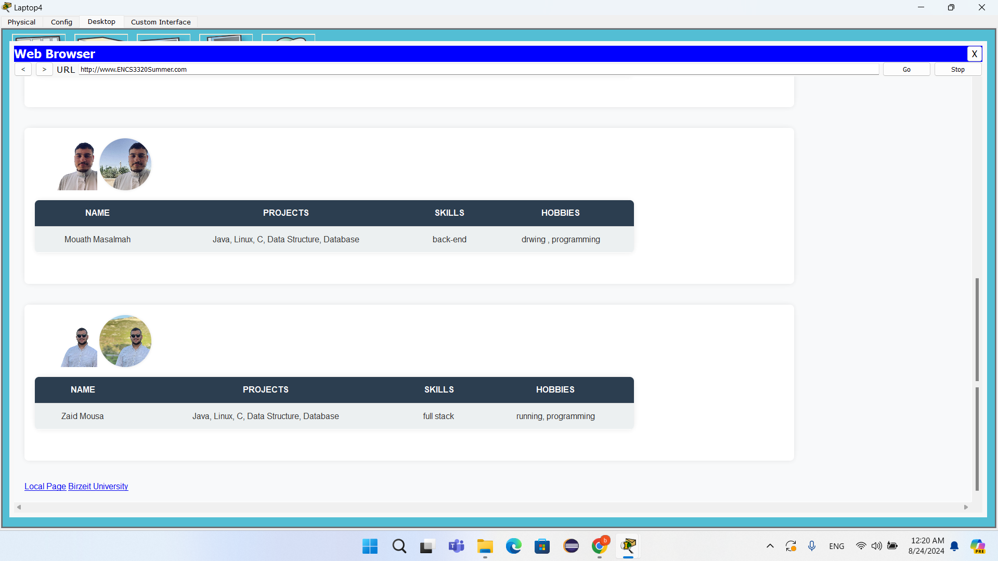

web page for Laptop4

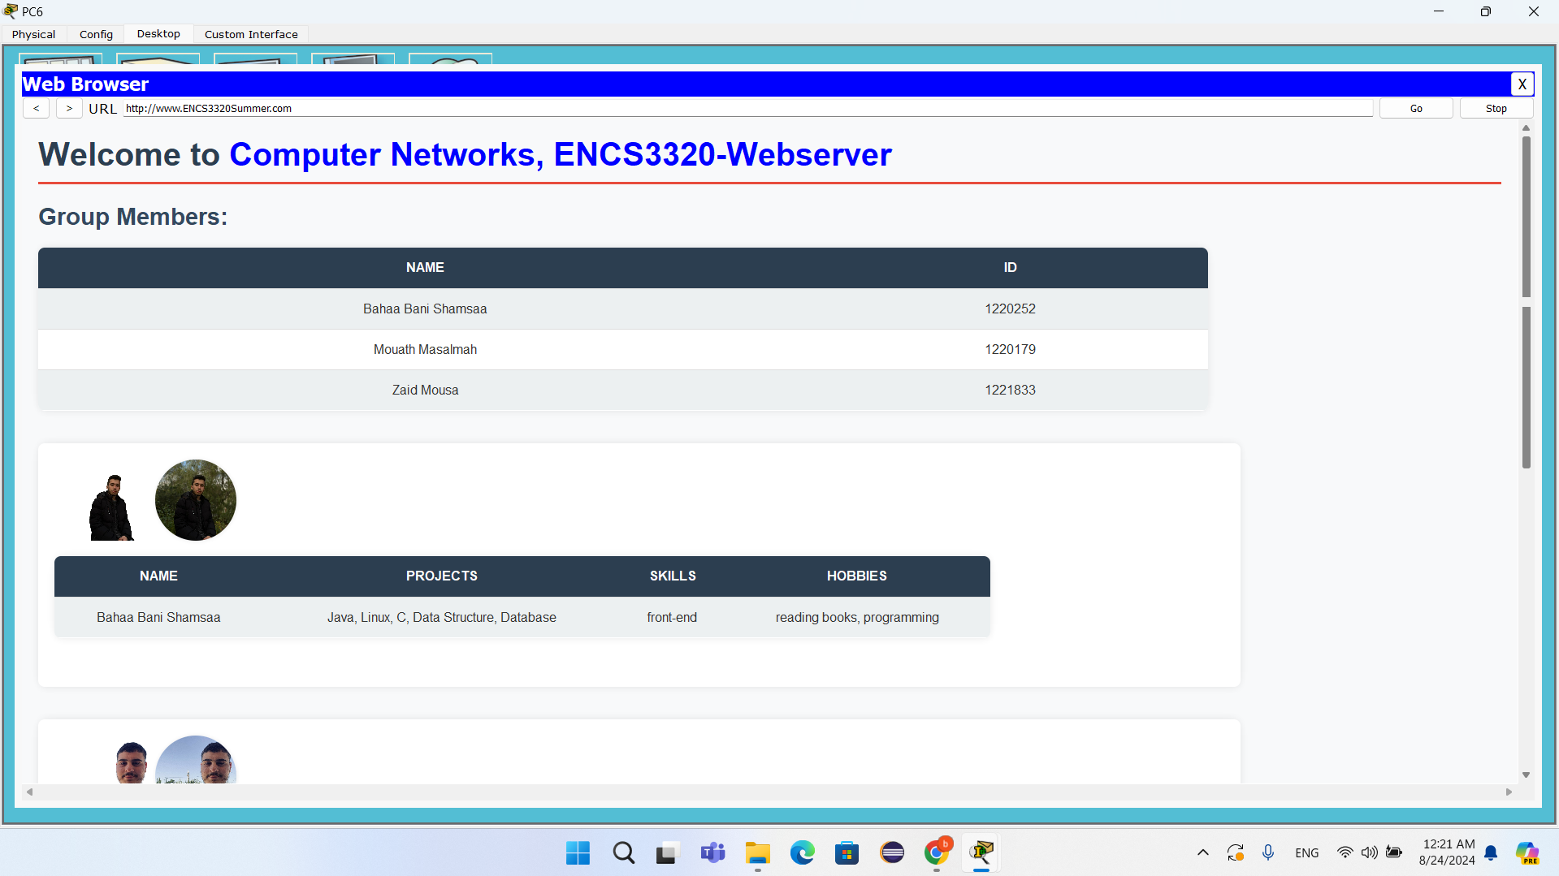

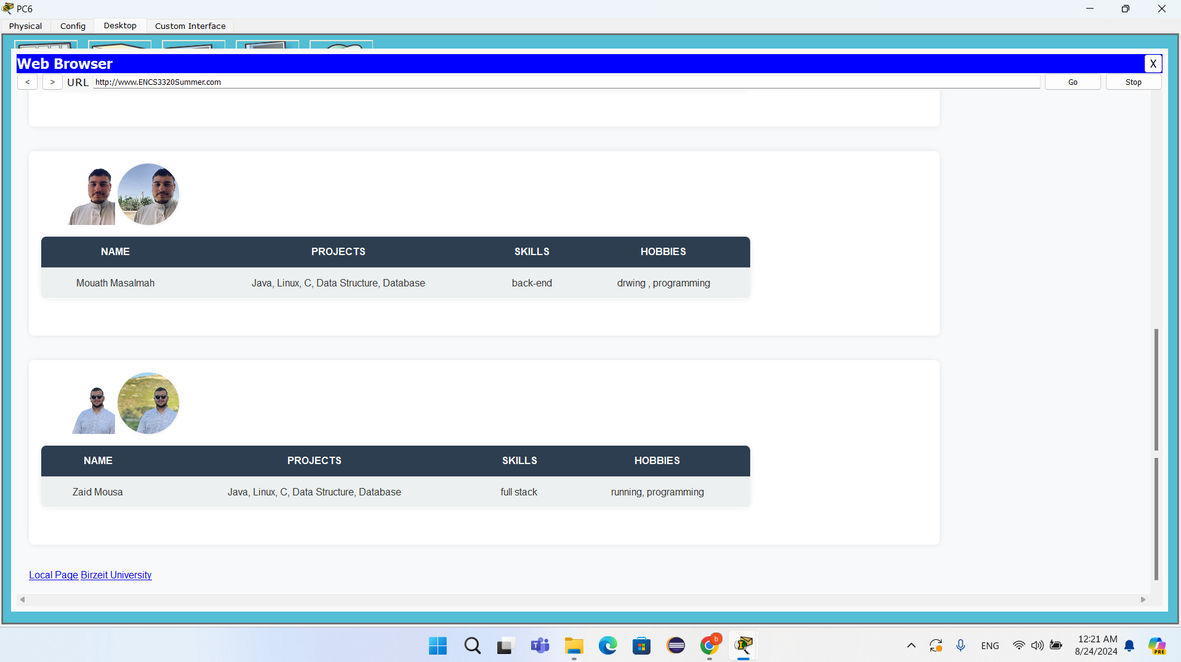

web page for PC6

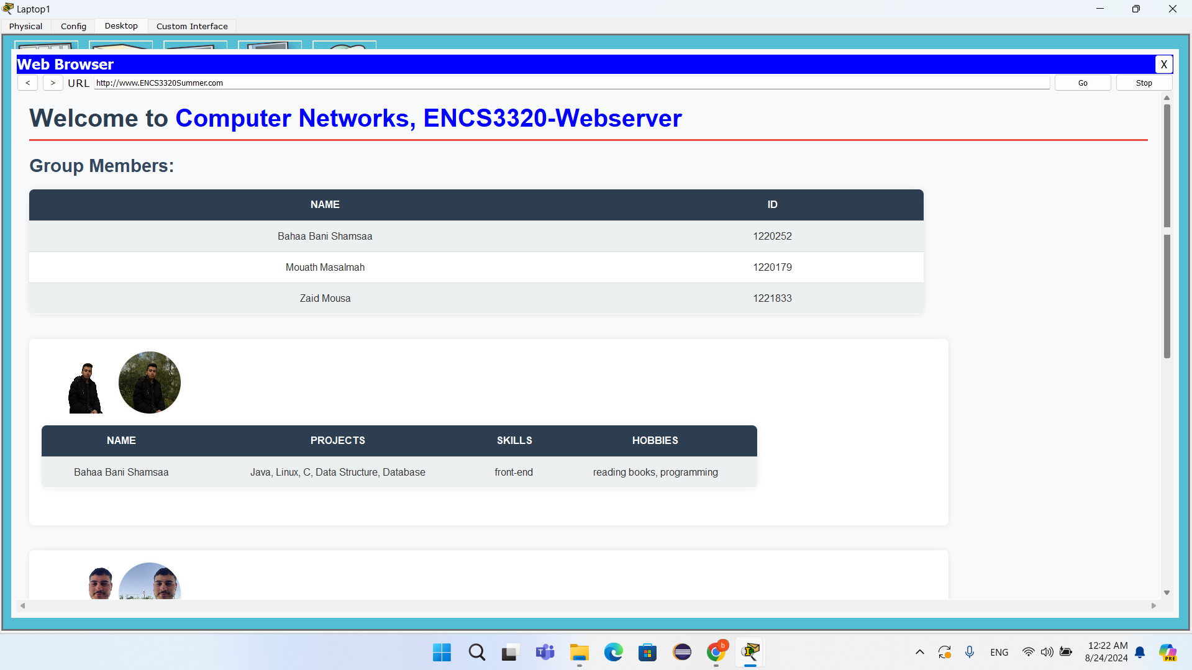

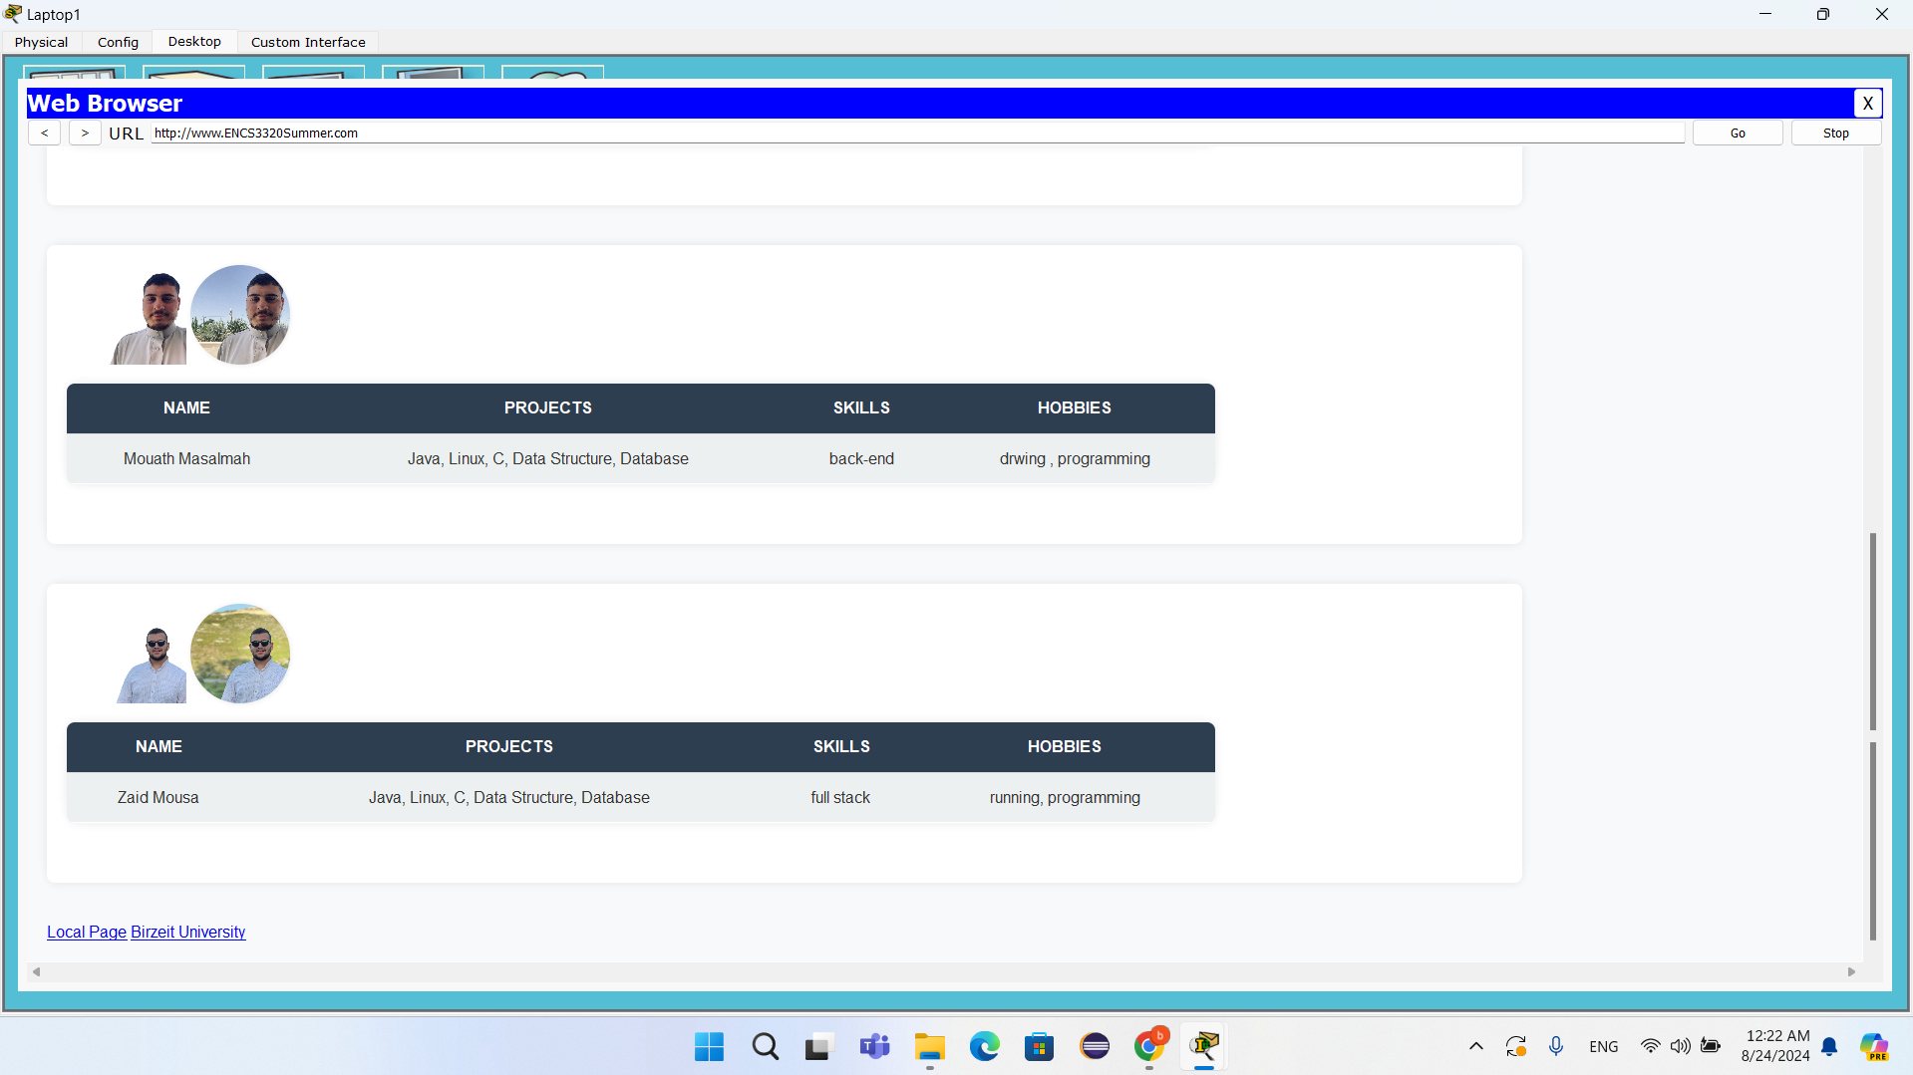

web page for Laptop1

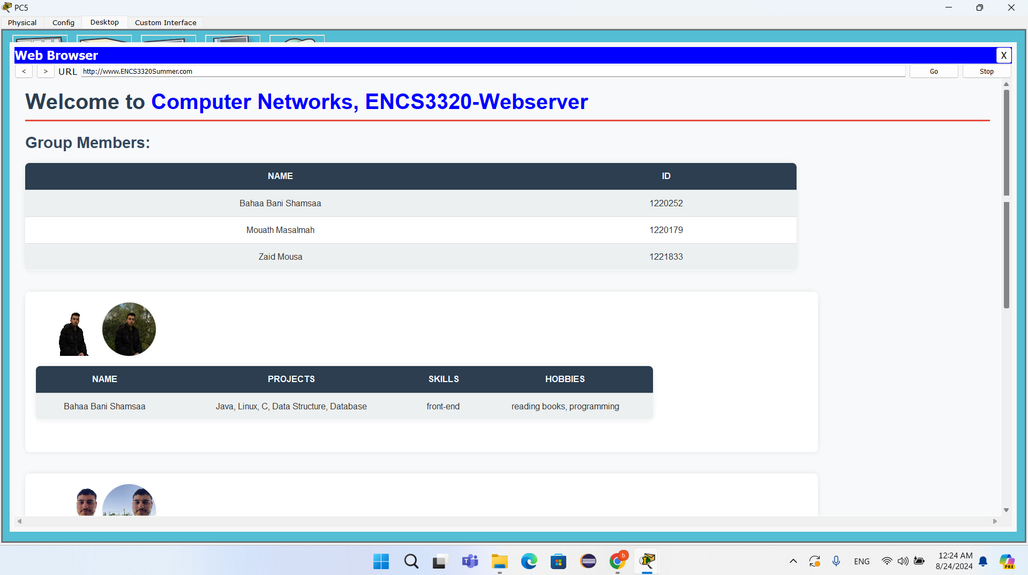

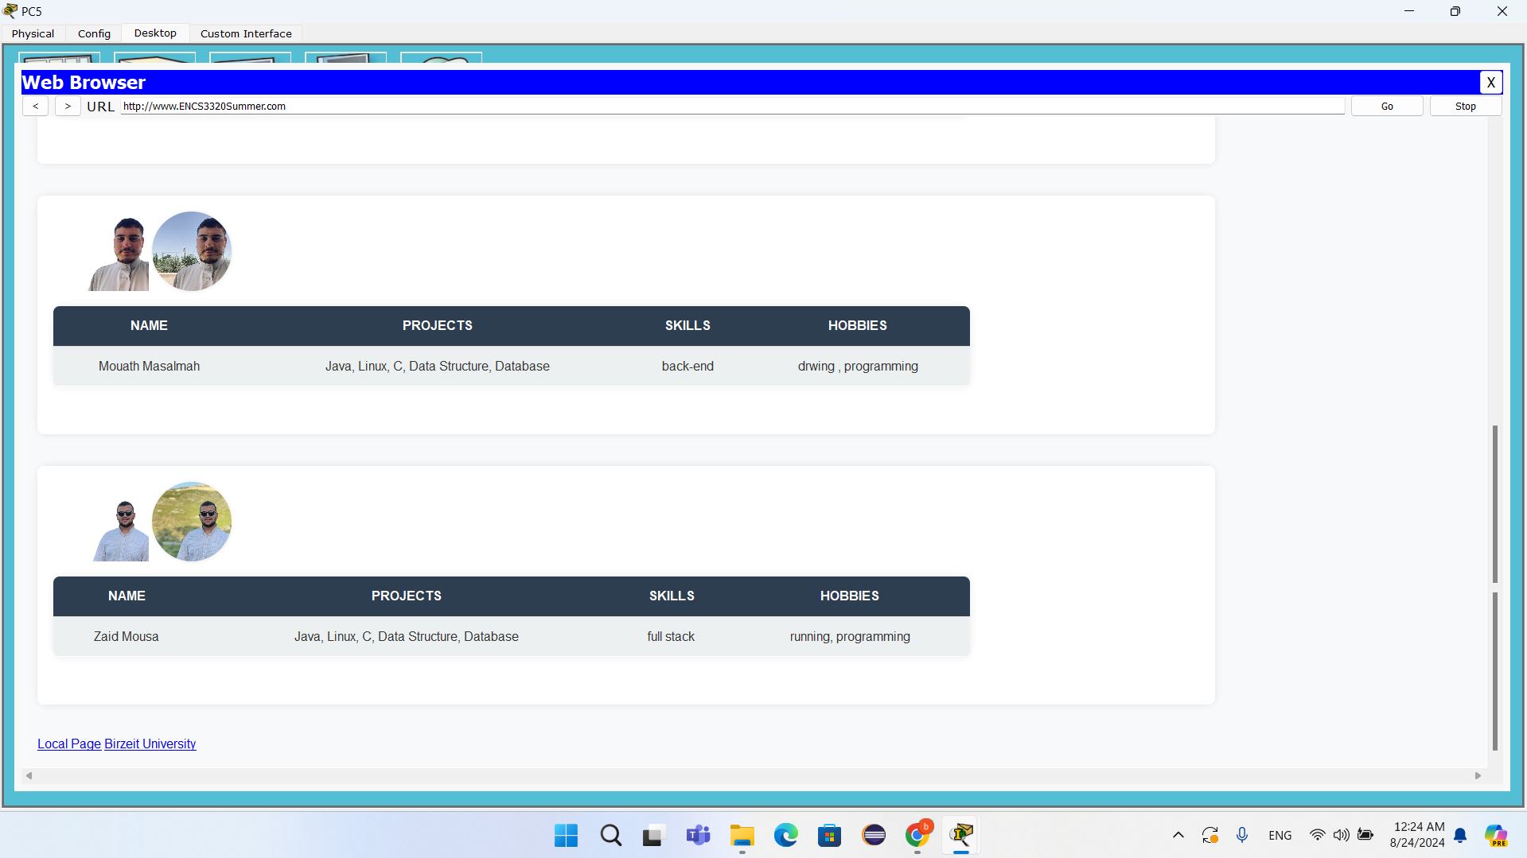

web page for PC5

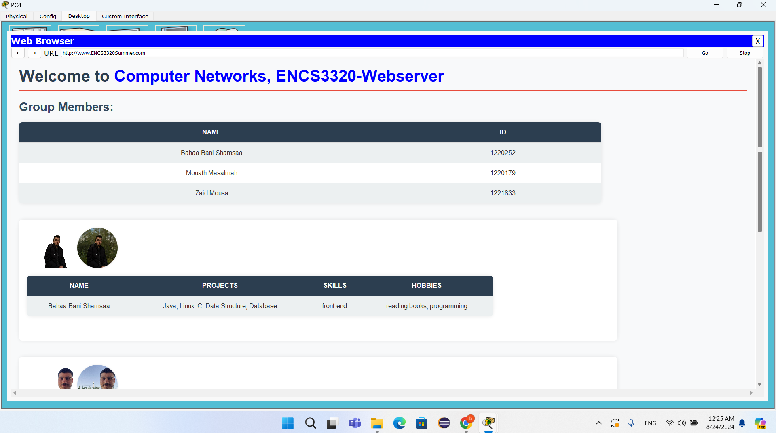

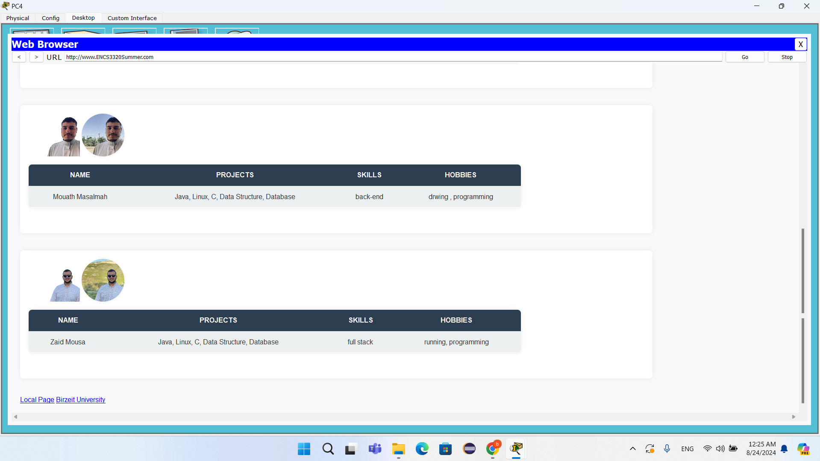

web page for PC4

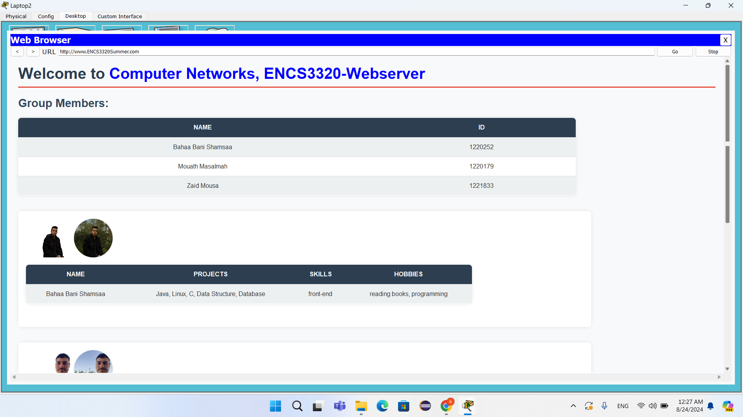

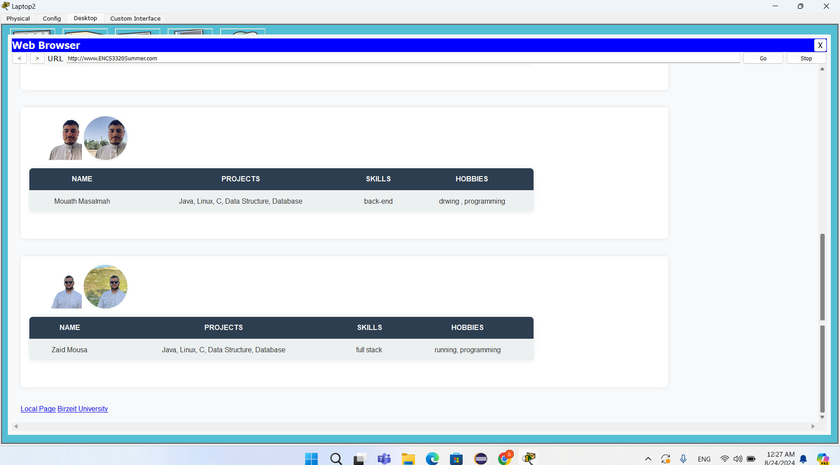

web page for Laptop2

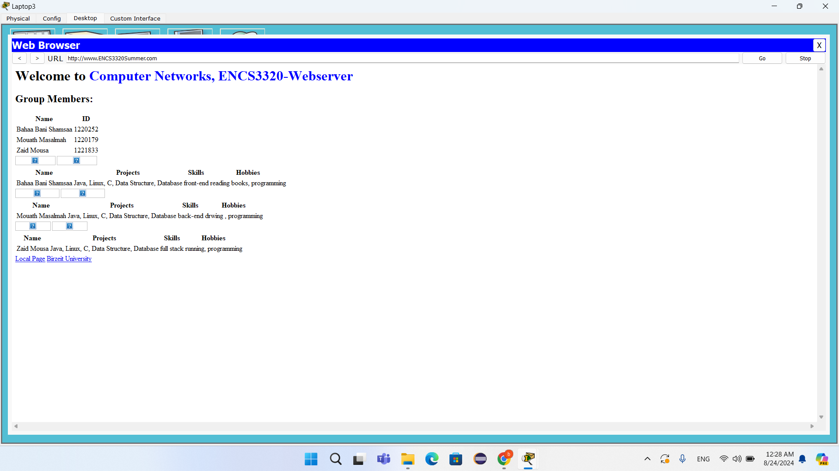

web page for Laptop3

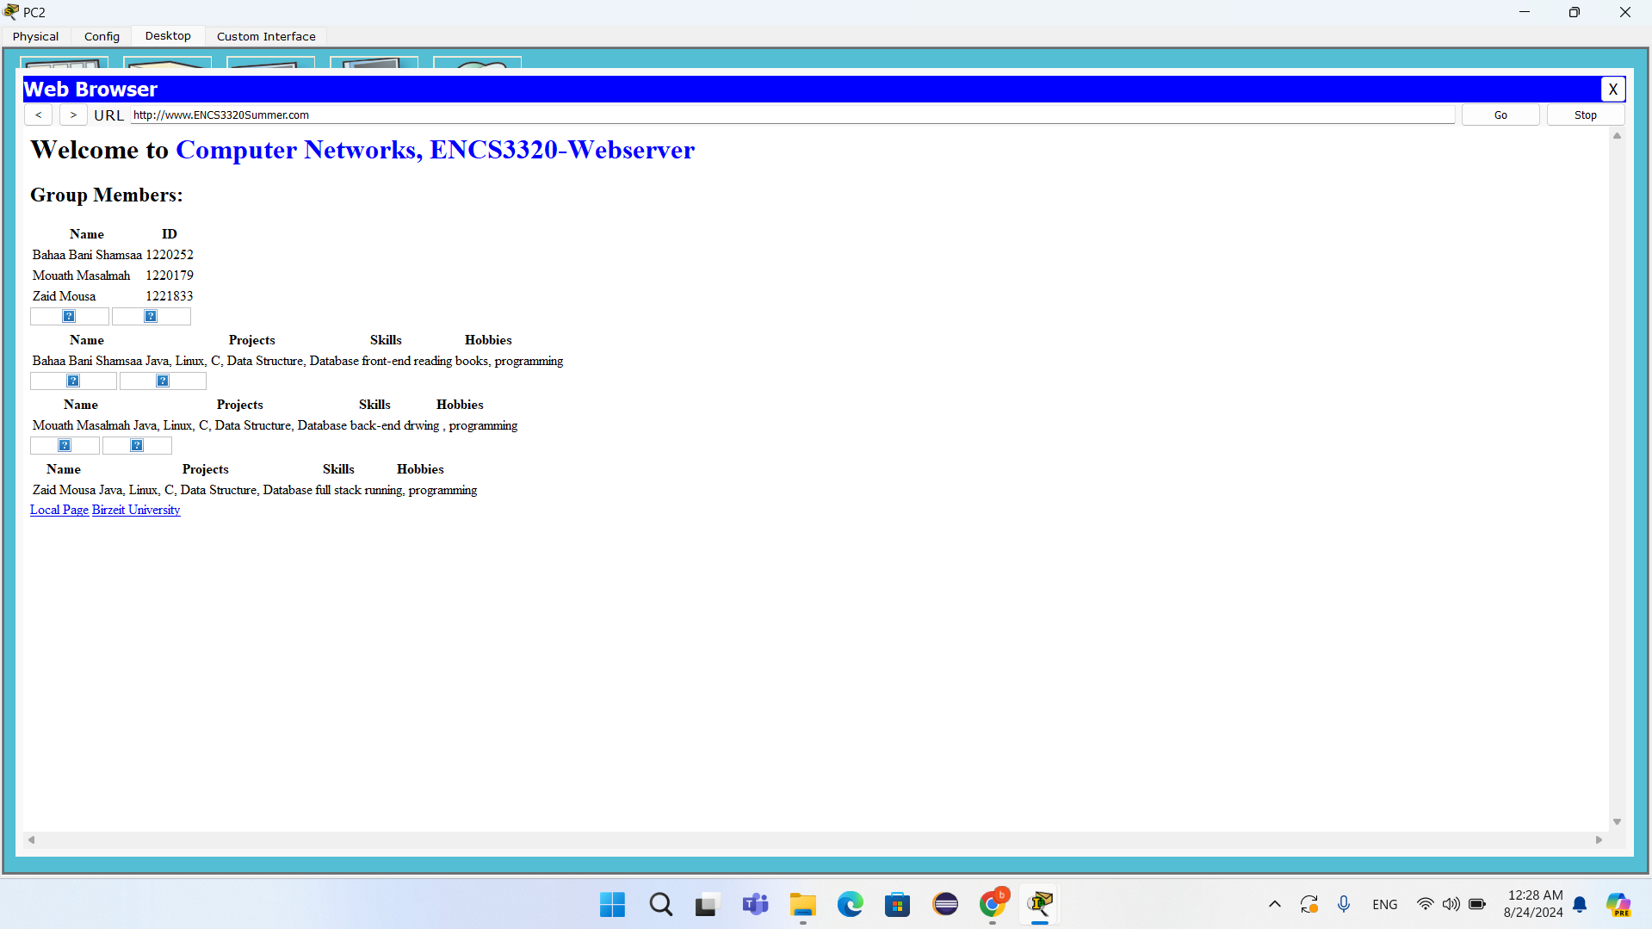

web page for PC2

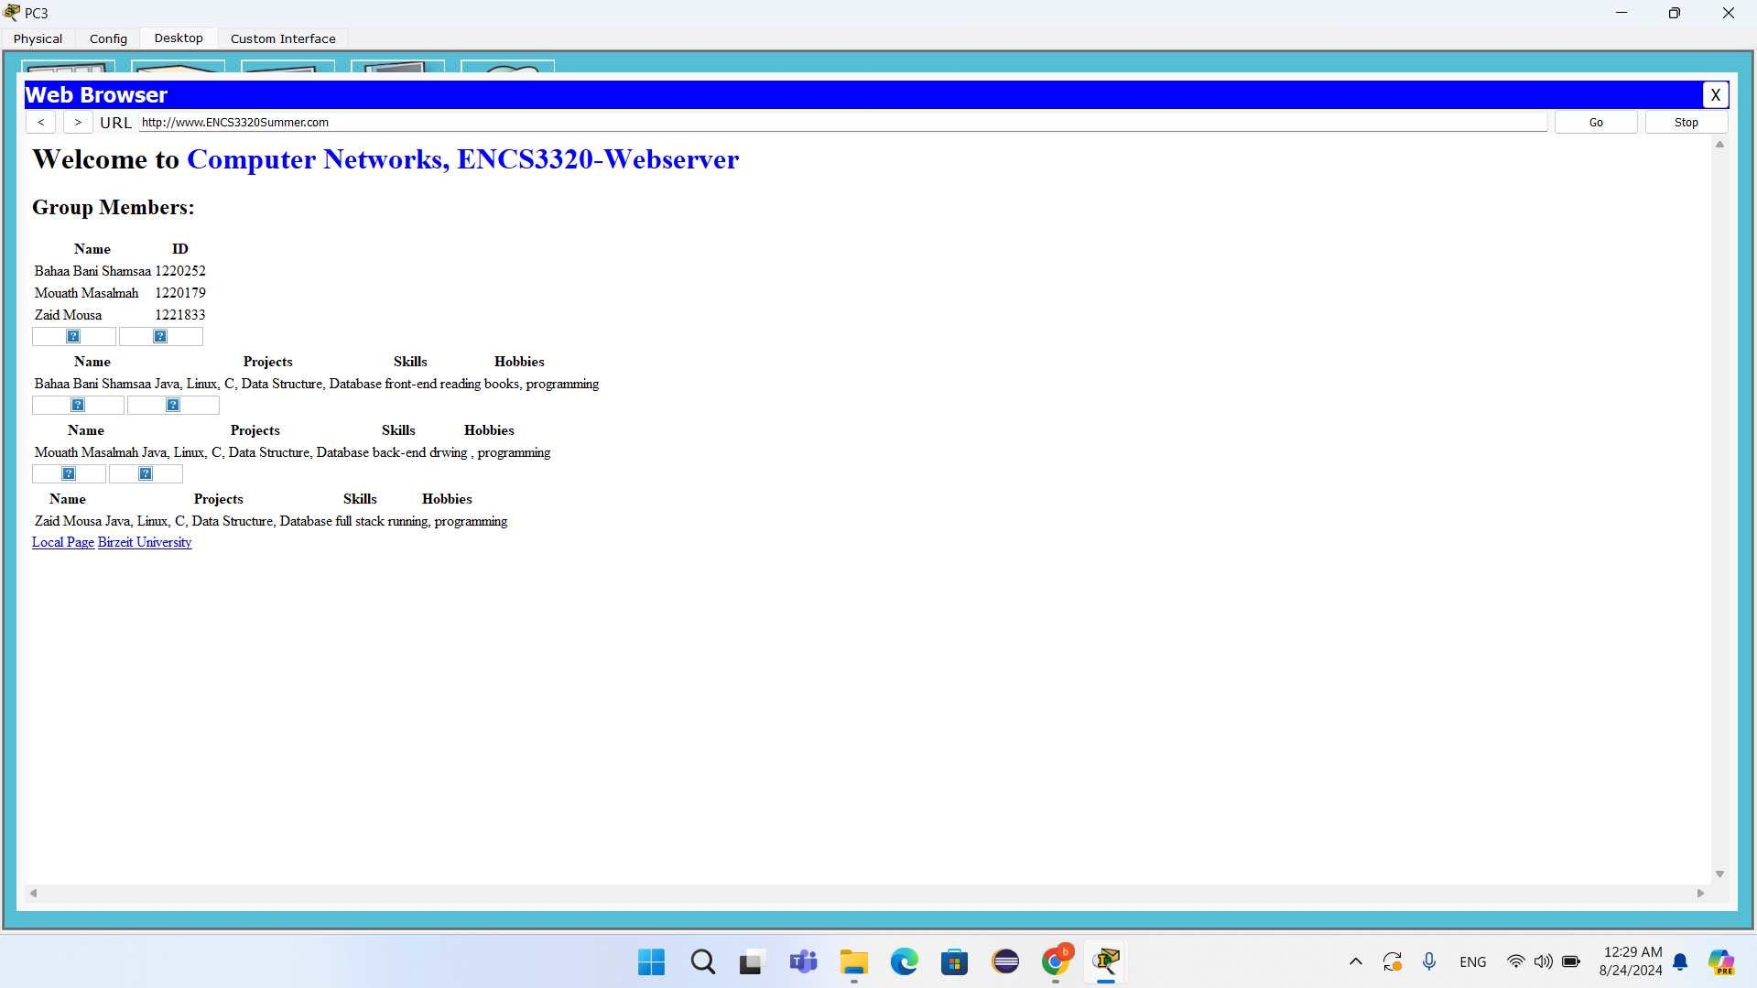

web page for PC3

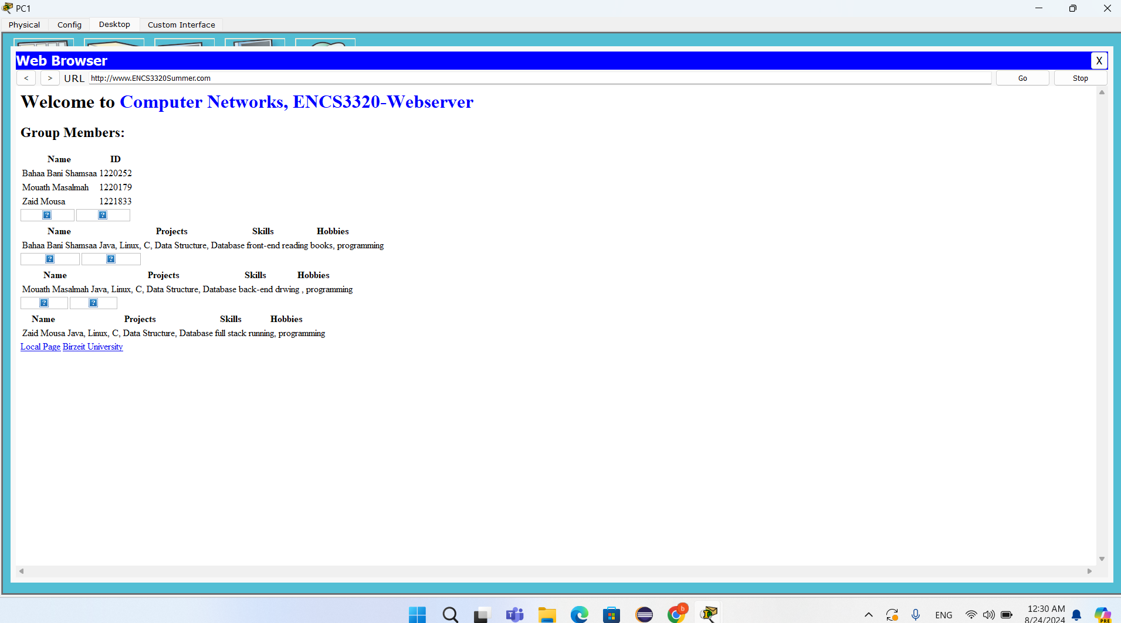

web page for PC1

# Pie Chart:

# Work and report:

Task 0: Mouath and Zaid

Task 1: Bahaa and Zaid

Task 2: Mouath , Bahaa and Zaid

Task 3: Mouath and Bahaa

Task 4: Mouath , Zaid and Bahaa

# The References:

* [IPv4](https://www.geeksforgeeks.org/what-is-ipv4/)
* [network Gateway](https://www.cisco.com/c/en/us/products/routers/what-is-a-network-gateway.html)
* [Packet Tracer](https://www.geeksforgeeks.org/what-is-cisco-packet-tracer/)
* [Subnet Mask](https://www.auvik.com/franklyit/blog/what-is-subnet-mask/)
* [Tracert](https://builtin.com/articles/traceroute)